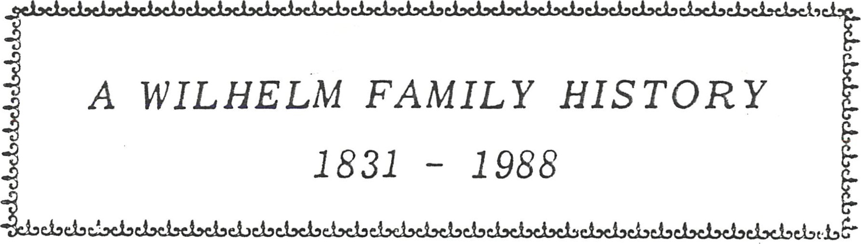
elseiscLe.beLOe..beLdseåsabc-isel»else.lsei'
el-RI'ehel.'
AN ABRIDGED COMPILATION

OF FAMILY DA TA
GATHERED FROM THE
FAMILY MEMBERS
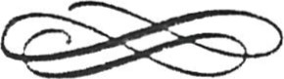
AND RECORDED HEREIN BY
BETTE CLARK (#174)
Sincere thanks to all who contributed

Wilhelm family history as {gund to date, 11 February 1988 from the records at the Mormon Genealogical Library
All records from Safenwil Parish, City of Koel liken, Canton of Aargau (State) in Switzerland
1 . Samuel Wilhelm, weaver, married Anna Schuermann, chr. 2 July
1765, daughter of Melchior Schuermann
Our great—great—great grandfather (Bette' s generation )
- Johanne Rudolph, chr. 16 August 1795; m. Anna Wehr Ii , in February 1823
[parents of Samuel who emigrated to USA/Canada — our great— great—grandf ather]
- Samuel, ch. 18 June 1797, died 14 February 1798 (church records) -
Only children of Samuel & Anna Schuermann Wilhelm located at, present . [grandparents of our Samuel who emigrated to Canada]
Family of Johanne Rudolph Wilhelm and Anna Wehr Ii Wilhelm
[Samuel' s parents] . Johanne R. was a Schreiner (carpenter) by trade.
- Anna, christened 11 December 1824, died in infancy .
- Andreas, male, christened 10 February 1826.
- Elizabeth, b. 9 Sept. 1827, christened 16 September 1827. 114. Rudolph, christened 21 July 1829. emigrated America
- *Samuel, b. 4 April 1831, christened 10 April 1831. * enigrat,ed America/ Canada z Our
- Anna #2, christened 28 December 1835.
- Maria, b. 20 April 1839, christened 12 May 1839.
- Johannes, b. 7 November 1840, christened 15 November 1840 .
- Elisa, b. 20 December 1844, christened 12 January 1845.
120 . Verena, Fem. born 25 October 1848, christened 15 November 1840 .
121. Maria Anna, b. 28 June 1843, christened 2 July 1843
Samuel' 5 birthdate and place are not, as listed in my
[Not all of the above 11 children lived past infancy.
1
LIST OF CHANGES ON THE FOLLOWING PAGES
New Cover Paqe - shows dates 1831 - 1988 to cover the update
Li st of Samuel s fami l y i n Swi tzer l and parents , grandparents , si bl i ngs.
Samuel Wi l hel m bi rthdate/ pl ace changed .
1 . Samuel bi rth date/ pl ace changed , new i nformati on added.
Pi cture capti on: Rose sai d i t i s Wal ter , not Ted , i n photo.
1 6. Thomas Al ex ander Horman added , #131 141 ,
Address gi ven for Davi d Horman , * 1312.
1B. New address & chi l dren added for 1314 Ruth Harman; new address for Margaret , #1 316.
1 9. Several changes on thi s page , mostl y spel l i ng of chi l dren s names.
20 . New address for # 1331 , Loi s Ki ng . New addresses 9 1333 Joan , 1 334 Frank ; new bi rth , } 13332 James Yacovi tch added.
New job & address #1341 , two new chi l dren , 1341 % 1 3412. New i nf o on #135 % new bi rth #1351 1 Trevor Ki ng ; new i nf o on 9 1 352 Davi d Car l Ki ng ; mi ddl e name added # 1 353 E #141121 added , Matthew Wettl aufer .
- husband Bi l l Kal bf l ei sch ' s death recorded.
Correct address #1421 Donna; new bi rth 1421 12 Kel l y; marri age # 14213, Karen Rudy/ James Tuff nai l . New bi rth , #1433 % Kurti s Charl es Garner .
44 , Marri age , #1455 Ki m ta Rocco Url ando,
New bi rth , #16313 { Mi chael Robert Wi l l i ams,
57. New bi rth ! #17212, Amanda Emma Wi l hel m.
- New address for Bette & Noel Cl ari^{t} end of 1988.
- Changes 174% 1742 , jobs , addresses.
61 . a 0b/ address changes , #1744 , 1745, New bi rth , 18213 Ki mberl y Davi dson.
New 18227 Gregory Pl ayer .
68. New bi rth , 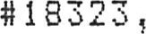 Meghan Wi l hel m. New bi rth , 1833% Jonathan Taves; marri age # 1834 , Carol yn Wi l hel m.
- . New marri age , #1842 , Steve Wi l hel m.
- . New address , Rose Kel l s , now i n Hi l l si de Nursi nq Home,
- . Death recorded , Kathl een , wi fe of 191 Kei th Kel l s.

75. New bi rth , # 1 Al yssa Ferenr
TABLE OF CONTENTS FAMILY PAGE
The Wilhelm Romance ( Samuel/Maadalena )
Samuel Wilhelm
Heideman' s
Recollections from Bette Clark
Wilhelm Family History1
Samuel & Magdalena' s Four Children2
Photo of Jacob, Annie & Elizabeth Wilhelm.3
1 . John and Minnie' s Family Listing4 Photo of John and Minnie Wilhelm6 Family Photo/John & Minnie' s Family.7
Photo of Family Gathering, Circa 1911.8
Photo of Family Reunion, Circa 1947 .9
- . Jacob Edward (Wilhelm) Williams .10
- . John Oscar Wilhelm14
- . Ida Elizabeth (Wilhelm) King15 14 . Theodore Robert Wilhelm.
1 5 . Minna Anna (Wilhelm) Kudob45
16 . Walter Frederick (Wilhelm) Williams .47
1 7 . Edwin John Samuel Wilhelm.54
1 8 . Albert Oscar Karl Wilhelm.62
1 9 . Rose Louise (Wilhelm) Kells.70 IA. Robert Rudolph Wilhelm
1B. Carl George Wilhelm.74
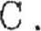George Arnold Wilhelm.76
TABLE OF CONTENTS
( Continued)
FAMILY  Continuation of Family Tree for Samuel' s Family | PAGE
Jacob Wilhelm. | 77
Annie (Wilhelm) Brueckner. | 78
Elizabeth Wilhelm. | 79
Theodore Heideman/Hu1da Luedke Family Listing. | 80
APPENDIX

Several pictures arrived after I had printed the full book; they are truly wonderful and I wanted to include them , so they are put at the end of the book. I hope you will enjoy them. 82
The following few pages are notes handed down from Ida, Ted and Berniece Wilhelm (Carl's wife) they should be interesting reading for the family members . (Recorded just as it was written. )
THE WILHELM ^{C} ROMANCE' ( Samuel )
They came from Berne, Switzerland, as far as I know, both sides, the Issler side also. You know the farm on Pork Street as you turn right when you leave Shakespeare . It's not far from that road that joins to Tavistock. Well this is from Aunt Lizzie Wilhelm, she used to talk for hours about such things. W. ( Samuel) was alone on the farm and it was pronounced Will um until folks just called them Wil— liams like all the English ones (Kings and all) — Wilhelms from Germany or around there. Well the neighbours asked him why he didn't take a wife instead of trying to farm alone, and then he could eat properly. He should get a wife to keep house. He said he'd like one but she must be so the man told him that there was a Swiss family living near New Hamburg and there were 4 girls living there. So gramps took off on horseback and came a—visiting with much to talk about and news from Switzerland, and that was about 1855. Anyway, there was 4 girls, but a man must always choose the oldest. so Magdalena, 28 years old, was chosen. The next time he came with sort of a wagon like type thing, piled gram and her belongings in it and went to Trinity Lutheran parsonage and tied the knot. Our dad was the oldest, then Jake, Annie and Lizzie. They probably didn't have much to start with, but the farmers along that road cut down trees for lumber for mills and firewood, and took it to nearby towns and there was money there for groceries, etc. (the land wasn't good, no drainage that's how the road became so poor) . They did everything from scratch. Grandma always kept a black sheep for wool for socks as our dad used to get sore feet from the dye, and then white sheep for winter clothes; then they wove the cloth, and cut it up for garments Anyway, they became the richest farmers in that area. Grandpa died young, fell off a load of hay and injured himself, so they said [ed. though some say he was hurt lumbering] . It was probably cancer. No will, so dad got the same by law as the others did. No education. Unk Jake was a veterinarian and was ahead, then, of course . So dad didn't get the farm, it was sold and divided and you know the rest. Buy hotels and lose money, etc. (Fryfogel Inn) so we really prospered after we came to Stratford.
P.S. The farmers in and around Sebastopol got together, Scotch and German mainly, and wanted a church. First asked a Presbyterian and he wouldn't come with the meager sum these farmers could pay, so the daddy' s met again and one Lutheran man spoke up and said how about asking a Lutheran pastor. They agreed and he came, hence Trinity Lutheran became the church and they got a school also a while before that. [ed. So the early Wilhelms were instrumental in helping set up the first school and first church in South Easthope Township]
Grandma (Magdalena) Wilhehn never did go to school, couldn't write, just made her mark. Oh yes! They came from Switzerland and were Presbyterian Zwingli.
[ed. Ulrich Zwingli was a Swiss Reformation Leader. 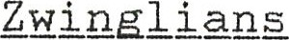 were those who followed Zwingli or his doctrines that Christ' s presence in the Eucharist is not corporeal but symbolic. ]
SAMUEL WILHELM
Samuel Wilhelm, born April 4, 1831 at Aargau, near Zurich, Switzerland , emigrated to New York City, U.S.A. a young man going to the California gold fields. On reaching New York a real estate agent persuaded him to travel to Ontario, Canada. He settled at Concession 2 , South Easthope township, clearing land and selling the logs for a number of years.
In 1865 Samuel married Magdalena Issler of South Easthope township. Magdalena was born in 1832 at the Issler Homestead near New Hamburg, Ontario . Her parents had emigrated from Switzerland prior to that date . Samuel and Magdalena had 4 children: John, Jacob, Annie and Elizabeth.
When John was about 17 years of age, ( 1880) , his father Samuel died from the result of an accident while transporting logs in the bush in the winter time .
John married Minnie Heideman - they had 12 children. (complete listing follows) .
Jacob married Mildred Hesse . He was a veterinary surgeon at Shakespeare, and later moved to Saskatoon. Two of his sons lived.
Anni e married Oscar Brueckner they had three chi Idren .
Elizabeth was a maiden lady, did practical nursing.
Samuel is buried at Trinity Lutheran Cemetery, Sebastopol.
Magdalena and Elizabeth are buried at Avondale Cemetery Stratford , in the Wilhelm plot . Jacob is buried at Woodlawn Cemetery, Saskatoon, Saskatchewan .
(from Berniece Wilhelm) Date of birth changed to agree with records found.
HEIDEMAN ' S Special family page on Grandma Wilhelm's family.
First the Heideman' s came around 1867 — maybe a year before. Mom was 9 years old on the boat. Ship Queen Victoria, 2nd trip Et.eam. Her sister Hulda, in Woodstock and brother Robert came 2 years before with the Uncle and Aunt Schoenheide, [the parents arranged that marriage for the kids, not the happiest but there was money] . Now our grandpa Heideman was a foreman in a cooper shop in Germany, a place that you can't find on the map in E . Germany. Pa used to call her a Mecklen— ger. So when he came here Uncle Will was about 16, mom was 9, the older ones went to other towns and married, you remember Albert and Rudolph, don't you? Zurich and Exeter? When mom landed here there was smallpox in Tavistock, so the family went to Hamilton where Robert surprised them by taking them to his home and introducing his wife Louisa to them. That was where he joined that church. I could tell you a lot more about this, but it is a lot of writing and I'm scribbling. Uncle got moved back here when the shops came and he was the boss in the Stratford shops He got our dad a job also and we moved here on Hallowe ' en night, 1899. [ed. The Mecklenger bit contradicts the birth data we have showing Minnie born in Wangerin, Germany] .

RECOLLECTIONS FROM BETTE CLARK
Being one of the youngest of the cousins, except for Rose's three youngest and Carl's children, I have fewer memories than most of you. I remember mostly going by grandma Wilhelm's house at 74 Blake Street, Stratford, each Sunday on the way home from Sunday School . There I'd meet my dad who had taken me to Sunday school and then he went to visit with Grandma and Uncle Carl who lived at home at that time . This was one of the coziest homes I can remember. Grandma had a large beautiful old stove I guess it was a Franklin in the living room, and it heated the whole house. Gram was always ^{t} old' to me, and I have no memory of grandpa at all he died when I was very young. 1 remember grandma being tiny ( short) with long blond hair that was usually worn in a long braid. She had a big kitchen with a large wood cookstove, and a large table that seated her big family in earlier days, and a pantry with a cloth curtain. (This may be wrong, but that's the way I remember it) . I can still picture the house as you entered from the side door into a cool enclosed outer area. , then into the house (kitchen) , and then into the living room with the lovely stove . There were two bedrooms off the livingroom, and upstairs there were several more . In later years grandma was confined to her bed, and cared for by Carl and Ida, who lived directly behind her on Mowatt; Street their yards were joined by a sidewalk and gated fence. The s e are happy memories, and I wish that I had more of them, but grandma died when I was fifteen years old. A. Ida's family should have a host of memories as they lived so close. Grandparen-bs are a wonderful institution I'm sorry my children were robbed' of theirs because we moved to the States That loss can never be repaid. The families chronicled on the following pages are descended from sturdy pioneers who helped to settle the South Easthope area.
I have recently found some pages sent by A. Ida in 1976 when she first asked me to consider doing the family history. At that time I had a large family still at home and a bad heart and told her I could not consider doing it then. These pages are mostly copies' of what has previously appeared, with a few changes . I don't know which account is correct — you can choose for yourselves . The following account is as I received it in 1976 -
The Heideman family came to Canada about 1867, maybe one year earlier. They came on one of the first British steamships named THE QUEEN VICTORIA. It took two weeks to get to New York. Two years before that, the oldest son, Robert, and daughter Hulda had come over with their uncle and aunt, the Ed Schoenheides. They had to come in a sailing vessel. No word came back to Germany from them and the family in Germany was in mourning . Then, five months later, a letter came from Hamilton, Ontario, telling them to come. Uncle Robert came to the Grand Trunk Station to meet them as they arrived and he took them to his home. He had found a wife, Louisa, and there they stayed for a few weeks. The place where there was a home to rent and possible work for the boy, was T avis tock. An epidemic of smallpox was on there . They settled in an old inn, no longer needed, in a hamlet called Balaclava, near T avis tock.
Grandpa was a foreman in a cooper shop in Germany . In Canada he ran his own shop in the large yard at his home . I still remember the shop and the shavings there. When I was quite small, I used to spend some time there . The veranda ran around two sides of the house, which was quite large. All the beds had a skirt around to hide the mattress; the same style did not come back until recent years .
His youngest son, Wilhelm, (Willy) was the only one who followed his father' s trade. He operated a cooper shop in Shakespeare, near Stratford.
Minnie was the youngest child (nine years old) on the boat. She had had three years schooling in Wangerin, Germany where she learned Latin, enabling her to learn English. In a few weeks in Tavist.ock, she was able to take her place in school with other children her age In her last year at school she won a prize in composition a book.
Names of the first family were:
Father : Theodore Heideman Mother : Hulda Leidke
- . Hulda married Edward Schoenheide , settled in Woodstock
- . Robert married Louisa, settled in Stratford
- . Albert settled in Zurich
- . Rudolph settled in Zurich
- . Edward settled in Exeter
- . Mary married John Seltzer and moved from Tavistock to Flint, Michigan
- . Wilhelm (Willy) settled in Shakespeare
- . Minnie married John Wilhelm, settled in Stratford
[ed. Some of the above is puzzling. Sounds as if Hulda married a cousin at least he had the same name as the (uncle' they had come over with. But the above is just as I received it from A. Ida. ] .

WILHELM FAMILY HISTORY
BEGINNING WITH SAMUEL WILHELM -
He was born April 4, 1831, baptized April 10 , 1831 at Aargau, near Zurich, Switzerland, emigrated to New York City en route to the Goldfields in California but was dissuaded from that venture and told to head for Canada. He settled near Shakespeare, Ontario where he farmed alone; he learned of another Swiss family living near New Hamburg, visited them and later married one of their daughters . He died November 10, 1880 after a logging accident on the farm. is buried at Trinity Lutheran Cemetery, Sebastopol, Ontario - he was called "Switzer Sam" by his friends and neighbors .

1 December 1987—
[ Through tedious digging' at the Mormon Genealogical Library his family record has been found. He was the 3rd son of Johanne Wilhelm and Anna Wehr li Wilhelm, and he had 10 brothers and sisters, at least two of whom also emigrated to America' . Their records can be inserted into your books at the end of the book or after Samuel's page, wherever you feel you want it to be so I don't have to do another 75 books !

He was married, on April 3, 1865 to
MAGDALENA ISSLER — daughter of Christ Issler and Anna ( Klein j i anni ) Issler — born in 1832 (or 1834), likely the first baby born in South Easthope Township. She died October 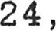 1915 , and is buried at Avondale Cemetery , Stratford , Ontario .
They had four children — see following pages.
1
WILHELM FAMILY HISTORY
BEGINNING WITH SAMUEL WILHELM
He was born April 3, 1831, at Berne, Switzerland, emigrated to New York City en route to the Goldfields in California but was dissuaded f rom that venture and told to head for Canada- He settled near Shakespeare, Ontario where he farmed alone; he learned of another Swiss family living near New Hamburg, visited them and later married one of their daughters . He died November 10, 1880 after a logging accident on the farm- He is buried at Trinity Lutheran Cemetery, Sebastopol, Ontario - he was called ' i Switzer Sam" by his friends and neighbors.
He was married, on April 3, 1865 to
MAGDALENA ISSLER — daughter of Christ Issler and Anna
(Kleinjianni) Issler - born in 1832 (or 1834) , likely the first baby born in South Easthope Township. She died October 24, 1915 , and is buried at Avondale Cemetery, Stratford, OntarioThey had four children see following pages.
[The Genealogical numbering system will begin with Samuel ' first son, John (#1) whose family is chronicled in the following pages.
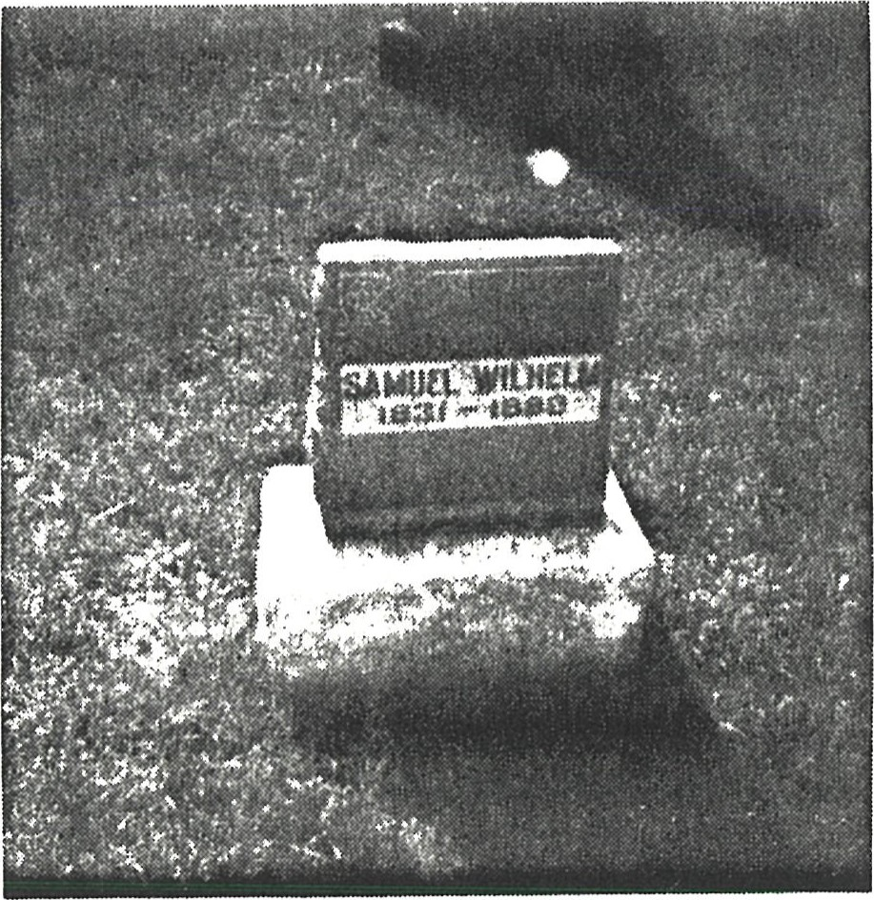
1
FOUR CHILDREN OF SAMUEL AND MAGDALENA ISSLER WILHELM
- . John Wilhelm born May 12, Id63 at Conc. 2, South Easthope Township, on the farm near Shakespeare, Ontario . He farmed on the homestead for some years, then following his fathers death he moved to Stratford and worked in the shops of the Grand Trunk Railway . He died on July 30, 1938 at age 75, (Florence King Horman said he died of what would now be called Altzheimer' s disease) and he is buried at Avondale Cemetery, Stratford, Ontario, Section 2B, I .
- . Jacob Wilhelm born January 2, 1865, at Conc. 1, South Easthope Township, near Shakespeare, Ontario. He moved west and settled near Saskatoon where he worked as a veterinarian. He married Mildred Hesse and they had two sons, Joe and Frank, and a daughter Magdalena who died in infancy from swallowing lye . He died February 4, 1938, and is buried at Woodlawn Ceme— tery, Saskatoon, Saskatchewan .
3 . | Annie Wilhelm
 | born March 7, 1868 | on the farm in South Easthope Township
 | near Shakespeare . | She married Oscar Brueckner, and they
 | had four children. | She died March 7, 1951, and she is
 | buried at Avondale | Cemetery, Stratford, Ontario .
4 . |  | Wilhelm
 | born April 3, 1871 | on the farm in South Easthope Township
 | near Shakespeare . | She died October 4, 1936, and is buried
at Avondale Cemetery, Stratford, On-bario. Age at death 65 years, 7 months, 1 day. She never married.
Families of these four early Wilhelm descendants are on the following pages with the bulk of the data on John,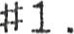
The pictures on the next few pages are real gems one of Jacob, Annie and Elizabeth Wilhelm ( # ' s 2, 3, 4 ) as well as one of John and Minnie, and two family photos of John and Minnie' s family. The one of the family with John and Minnie was, I believe, taken at Jacob's wedding in 1911 as both Jake and Oscar were wearing lapel flowers as they were on his wedding photo in his section following.
2
Jacob , Annie and Elizabeth Wilhelm, circa 1888—1890 THIS IS THE FAMILY HISTORY FOR DESCENDANTS OF JOHN WILHELM / MINNIE HEIDEMAN, AND ON FOLLOWING PAGES FOR THE BROTHER AND SISTERS OF JOHN WILHELM.

1 . J Ohn Wilhelm, born May 12, 1863, married in 1884 (Zion Parish
Register) to Minnie Heideman, born June 14, 1865 in Wangerin, Prussia, Germany- They lived first on different farms and then moved to Stratford where they lived at 74 Blake Street . John died July 30, 1938, and Minnie died on November 21, 1949. They are buried at Avondale Cemetery, Stratford, Ontario . From this union there were 12 children: an unofficial count of the descendants listed in this history totals 239 . Children: 12; Grandchildren: 36; Great—Grandchi1dren : 90; Great—great
Grandchildren 98; and Great—great—great grandchildren: 3 !
The original family farmed on Pork Street at the corner of the Shakespeare to T avis tock Road. John (whose descendants are chronicled on the following pages) married Minnie Heideman who was the youngest of the Theodore Heideman family. When she was nine years old she and her parents landed in New York and -bra— veled to Hamilton where her brother Robert lived. All the brothers had previously been packed off to America to avoid the draft. When they reached the draft age somehow the money was found for passage to Canada. Theodore Heideman was a cooper. The ship that they crossed the Atlantic on (the Queen Victoria) was one of the first steamships equipped with sails just in case. Her brother Robert and sister Hulda (who lived in Wood— stock) and the other siblings had come earlier by sail with their Uncle and Aunt Schoenheide . that crossing took 3 months, and the family thought they were dead.
Easthope for whom the Township was named was a surveyor along the Huron tract. — (from Florence King Horman)] .

1 1 . Jacob Edward Wilhelm, later changed his surname to Williams . He was born September 3, 1885, and died March 11, 1955 . He married twice, to Elizabeth Menzies, and later to Ida Winegarden. He had four children by his first marriage . He operated a welding/ machine shop in London, Ontario, and had a sign above the door that read "1 will weld anything but the break of day" . They say he would ^{R} tackle anything' .
1 2 . John Oscar Wilhelm, born December 13, 1887, died in 1912 in his 25th year in a runaway horse accident . He never married.
- . Ida Elizabeth (Wilhelm) King, born July 30, 1889, died on March 1 , 1986, in her 97th year. She married Frank King on September 5, 1911. They had three sons and two daughters .
4
- . Theodore Robert Wilhelm, born May 7, 1891, died May 30, 1977 in Lakeland, Florida. He married twice, first to Flora Krug, and they had six children, (one stillborn) . He was a lifelong farmer in East Zorra Township. Ted remarried after Flora's death to Jennie Watson.
- . Minna Anna (Wilhelm) Nahrgang Dickson Kudob, was born on March 29, 1893, and died May 2, 1982, age 89. She was married three times and had one son by her second marriage and a daughter by her third marriage .
- . Walter Frederick Wilhelm, later changed his surname to Williams .
He was born on March 30, 1895 and died on July 14, 1962 in Flint, Michigan. He had moved to the United States early in his life and married Bessie Bittner. He worked for the City of Flint, and for the Chevrolet Division of General Motors. He also served in the US Army during WWI . They had two sons, and a daughter who died at premature birth caused by a fall.
- . Edwin John Samuel Wilhelm, born February 5, 1897 in Baden ,
Ontario, and died on February 15, 1950 from an accidental fall at his home. He married Emma Marie Heinbuch on September 19, 1923. They lived all their life in Stratford where he worked for the CNR shops, and later bought a farm. He served in the Canadian Army during WWI . They had four children.
- . Albert Oscar Karl Wilhelm, was born August 24, 1899 and died from a heart attack on January 17, 1945. He married Edna Anna Schaefer on September 19, 1921 . They lived all their life in
Stratford where he worked at the CNR shops . They had four sons.
- . Rose Louise (Wilhelm) Kells, born July 17, 1901 in Strat— ford. She married Moore Kells on October 16, 1926. He died on December 16, 1974. They lived all their life in Mitchell, Ontario, where he was a drover and later a farmer. They had six chi 1 dren .
IA. Robert Rudolph Wilhelm, born June 23, 1903, died May 13, 1928 of heart failure. Ida said in the early 1980's that he was born with a hole in his heart. He never married.
1B. Carl George Wilhelm, born October 20, 1904 in Stratford. He married Leta  McKay on April 28, 1951. He lived with his mother in Stratford for the early years where he worked at the CNR shops. After his marriage he farmed in East Zorra Township, Oxford County .
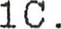George Arnold Wilhelm was born on February 8, 1907 in Strat— ford. He died of diphtheria on September 17 , 1910 .
THIS CONCLUDES THE LISTING OF THE FAMILY OF JOHN AND MINNIE (HEIDEMAN) WILHELM. Complete family listings follow. Photo of John and Minnie, and a family photo follow.
5
qork 01 othes
1920' s or earW 1930' s
John and Millilie
Circa
A Very Well Dressed Family - Circa 1910
Back Row: Walter, (not Ted) Ed, Oscar, Jake
Center : Ida, Minnie, Rose
Front row: Robert, Bert, Carl (Corrected per Rose )
809
A Very Well Dressed Family Circa 1910
Back Row: Ted, Ed, Oscar, Jake Center : Ida, Minnie, Rose
Front row: Robert, Bert, Carl

の 。 の8 のdpロ E) 20 2ミpロ2自0 'pa 。のの0
① 2づ 'pea-I 'EPI 《 ①や の ロロ 【 20S0

tt6t t-ITPPemS の の 2 2 ー ロ のよゼ

THIS PHOTO WAS TAKEN AT A WILHELM FAMILY REUNION AT QUEENS PARK IN STRATFORD - BELIEVED TO BE IN 1947.
Pictured on this family reunion photo believed to be 1947:
Back row | Gladys McGregor, Joyce Kens, Muriel Wilhelm, Bill  Pollard, Emma Wilhelm, Jeanne Wettlaufer, Florence  Horman, Eileen Kudob, Lois McCallum, Allan Dickson, Carl Wilhelm, Glenn Wilhelm, Lenore Wilhelm, Harold  Wilhelm, Lyla Her lick, Bette Wilhelm (holding Linda Wilhelm) , Flora Wilhelm, Gordon McGregor, Fred Kudob, Ethel Pollard.
Front row | Carl King, Frank King, Ed Wilhelm, Ted Wilhelm, Jake Williams, Minnie Wilhelm, Rose Kells, Ida King, Edith Wilhelm, Jean Wilhelm.
Children — | Joyce and Donna McGregor, Betty Horman, Arlene Wilhelm, Jack Horman, Sandra Wilhelm, David Horman or Bill Pol— lard, Robert Kells, Kenny Wilhelm, Glenn Kells, and either David Horman or Bill Pollard, Jr. Some of the children may be misnamed sorry, I tried!
Missing | Minnie Kudob, Walter Williams and family, Bert's family, George Wilhelm, Frank and Melvin King, and others .
JACOB EDWARD WILLIAMS LONDON, ONTARIO
1 1 . Jacob Edward (Wilhelm) Williams was born September 3,
1885, died March 11, 1955 . He is buried in Section 1, Lot
134, Mt. Pleasant Cemetery, Riverside Crescent, London, Ontario. He operated his own welding/machine shop, and had a sign over the door, that read ^{il} l will weld anything but the break of day" They say he would tackle anything !
In 1911 he married ( 1 ) Elizabeth Margaret Lindsay Menzies, born July 2, 1889 in North Easthope Township, and died on July 31, 1927 in a traffic accident. She is buried at Avondale Cemetery, Stratford, Ontario. From this union there were four children: Jack, Kenneth, Annabelle and Elizabeth (Betty) . The name change from Wilhelm to Williams was never registered according to Marion, Ken's widow. Below is a wedding photo showing Oscar, Jake, Elizabeth and her sister Annabelle Menzies 1911 .
1 1 1 . John (Jack) Irwin (Wilhelm) Williams , born April 26, 1912.
He married Eleanor Beatrice Bishop, born April 26, 1916 . They had three daughters (one, a twin of Betty, died at birth) .
Elizabeth (Betty) Williams, born September 1 , 1937 . She may still be alive, but nothing more is known. Her twin died at birth. Last known she was in a hospital in Cobourg, Ontario, in the 1960' s.
- . Twin of Elizabeth, died at birth.
- . Carol Williams, born March 14, 1944. She married, no more details are known about her, or this family.
1 12 . William (Wilhelm) Williams, was born July 14, 1914, and he died of polio on November 19, 1953. On June 8, 1946 at, All Saints Anglican Church, London, Ontario he married Harriet Marion Risler, born November 22, 1913. He worked until 1950 in the family welding business, then left and worked for James Cowan Machine Shop. From 1951 to 1953 he was a front end welder for General Motors Diesel. He was a member of the Masonic Lodge . They had one son, David. Marion survives, and lives at 26 Bond Street, London, Ontario, in the home she and Ken built. Ken is buried in the Risler family plot, Section G, at Woodland Cemetery, Springbank Drive, London.
Ken and Marion's wedding David's UWO Graduation, picture, June B , 1946. 1969
fit
1121 . David Kenneth Williams, born November 21, 1947 in London. He has several degrees, A. Music, and Music Bachelor (1969) from UWO majoring in Piano and Trombone, but he had to learn all instruments including strings . He teaches Brass and Percussions . He taught music in Well and, and Sudbury Ontario and moved back to London where he is now teaching at A. B. Lucas Secondary School. On July 26, 1975 in Sudbury he married Margaret Ann Basha, born April 26, 194.3 , and they now live in London. They have two sons .
- . Robert David Williams, born August 15, 1976 .
- . Douglas Kenneth Joseph Williams , born June 30, 1978 .
This is a photo of Annabelle, Kenneth and Jack, circa 1918.
1 13 . Annabelle Marguerite (Wilhelm) Williams, born March 12,
1916 . On January 18, 1941 she married Charles Chuck" Edgar, born 9 December 1914. Chuck worked as a route salesman for the Silverwood Dairy and he is now retired and lives at 1260 Hillcrest Avenue, in London. Annabelle died on July 22, 1973 and she is buried at Woodland Cemetery, in London. They had three children.
1131 . Robert Douglas Edgar, born February 20, 1942. On May 13,
1967 he married Eileen Campbell McCallum, born September
27, 1943. Robert graduated from the University of Western Ontario and works ^{t} ' in Computers" at London Life, in London.
they have two children, and live at 112 Cant ley Crescent, in London .
- . Sandra Michelle Edgar, born June 19, 1970 .
- . Jeffrey Robert Edgar, born October 8 , 1973 .
1132 . Donald Kenneth Edgar, born October 4 , 19 4 4 . On August 10,
1973 he married Maureen Elizabeth Connell, born August 27 ,
1950 . Donald is a graduate of the University of Western
Ontario and he teaches the mentally handicapped at a London High School . They have four children, and live at 26 Abbey Rise, in London.
- . Nancy Marie Edgar, born October 26, 1977
- . Patricia Anne Edgar, born May 16, 1979 .
- . Heather Lynn Edgar, born June 14, 1982 .
11.324 . Steven Charles Edgar, born May 1 , 1984 .
1133 . Suzanne Eileen Edgar, born June 19, 1948. On 31 August 1968 she married Michael David Stewart, born February 17, 194B . Suzanne has her B.A. from the University of Waterloo, and Michael is a tool and die maker and works as plant manager of a machine manufacturing company near Kitchener . have three daughters and live at 19 By ton Lane, in Cambridge, Ontario .
- . Wendy Stewart, born April 8, 1971 .
- . Margaret Anne Stewart, born June 11 , 1974 .
- . Kathryn Suzanne Stewart, born July 6, 1979 .
1 14 . Elizabeth (Betty) Williams, born 1923 died with her mother in an auto accident on July 31, 1927 .

Jacob married ( 2 ) in 1928 or 1929 to Gatecliffe) , born 1891, died October
JOHN OSCAR WILHELM
12 . John Oscar Wilhelm was born December Ida Winegarden (nee
6 , 1960, aged 69 years.
13 , 1887, died

1912 , aged 25 years, in a runaway horse accident . He was a tall, handsome man, never married
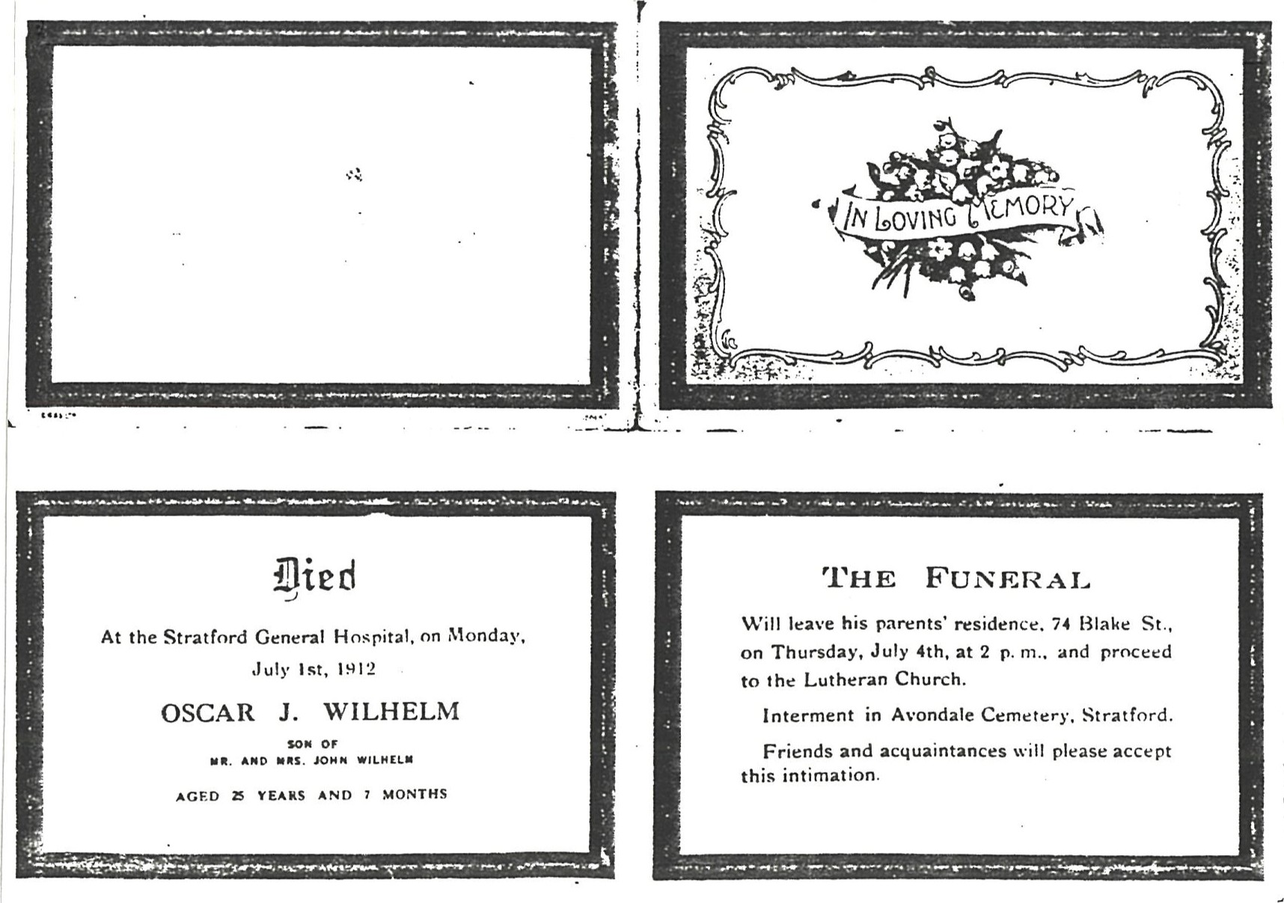

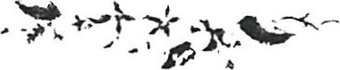
In Loving 06
IPA ELIZABETH (WILHELM) KING
Juzy 30, - 1, 1986
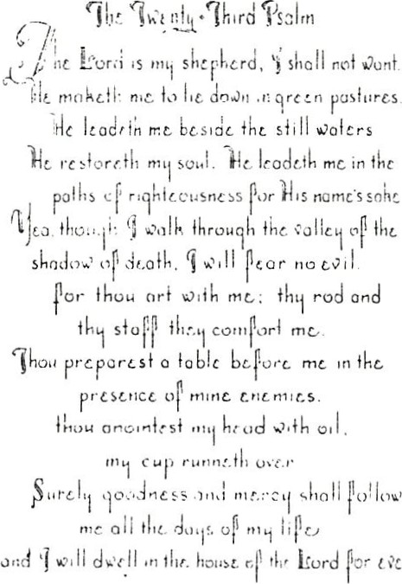
Age %
&0tr.
WZ6e 06 the Rate
Funk rang (7959)
Vean Mothe,t 06
Funk 6 vide Hi.-Zda 6 wZ6e Hugeüe
Cant- 6 hZ.,5 wZ6c Bonn-de
. FZoaence Hotman uu. EtheZ
Pean SO Zen o an e m uu. Rue KeZ&
"L,'tvzved by
18 gundchü-daen, 16 gZ.g*tandchivZd'to:
Func.'uae éenvzce heed at
ZZon EvangeUcaZ Luthenan Chanch Monday Manch 3, 7986 at 1 :30 p.m. Rev. VonaZd Saoh 066ZcZazed
Intenmenz kn AvondaZe Cemetety Staat60ad, (.)nzarå-o
Heinbuck Funenae Home
IDA ELIZABETH WILHELM KING - STRATFORD, ONTARIO
13 . Ida Elizabeth Magdelina Wilhelm was born July 30, 1889, and she died March 1, 1986 in her 97th year. She was married September 5, 1911 to Franklin King, (Anglican) born December 25, 1881 in Stratford, Ontario. Their marriage was the first performed at the new Zion Evangelical Lutheran Church, Stratford, Ontario. Shortly after their marriage the Grand
Trunk Railway was laying off people so they moved to Rivers , Manitoba where he worked on the railway some times and also trapped a 30 mile line on the Saskatchewan River; he also tended a rink. They moved back to Stratford and lived at 94 Mowatt Street — which was connected by a sidewalk back through a gate to her mother' s home at 74 Blake Street; and Frank worked at the Grand Trunk/ CNR railway, and also did paperhanging. He was a jovial happy—go-lucky person and it was fun just being around him. Frank died in August 1959, Ida in March 1986, and they are buried in Avondale Cemetery, Stratford, Ontario . She was a great mover in arranging family reunions, in keeping family records and in doing the family tree.
From this marriage there were five children: Florence, Ethel, Frank Jr. , Melvin and Carl.
Below is an old snapshot showing Frank, Ida and the three boys, taken at their front stairs at 94 Mowatt Street in Stratford .
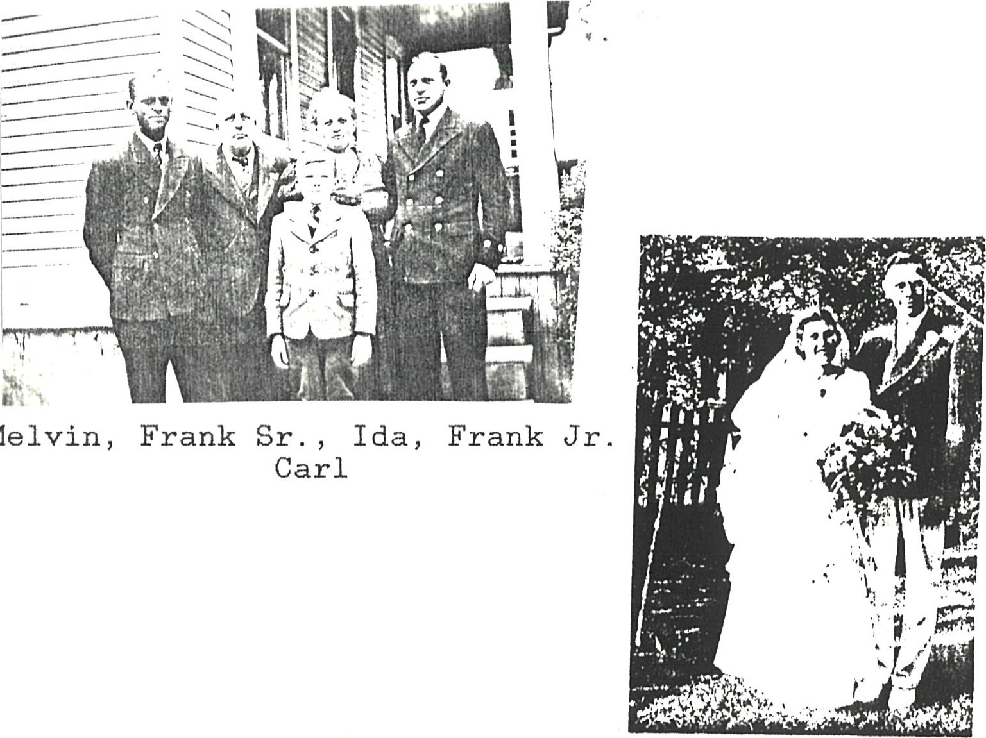
Melvin,
Florence and John Horman
July 22, 1939

15
Florence Minnie King was born on October 15, 1914; she graduated from Stratford Normal School as an elementary school teacher . On July 22, 1939 she married John Wilfrid Horman, born July 30 , 1910; he died on September 29 , 1964 from a heart attack. John was a f armer , and they moved to his farm following their marriage . In 1948 they sold the farm and moved to Sebastopol where they had an implement and garage business until 1957 . Then they moved to Waterloo and John was a Real Estate agent until September 1964.
Florence worked as a circulation assistant at Waterloo Lutheran University Library , (now Wilfrid Laurier University) . They had six children:
Florence currently lives at 49 Norman Street, Waterloo , Ontario, Canada N2L IG4, (519) 744-9655.
1311 . John Franklin ( Jack) Horman, born in Stratford on June
21 , 1940 . He has a B.A. in Classics from Waterloo Lutheran University, an M. A . in Classics from McMaster University in Hamilton, a Bach. Divinity from Waterloo Lutheran Seminary and a PhD. in Religion from McMaster University which he obtained following his marriage. He works at Prudential Life in Kitchener and is a computer programmer . In 1966 he married Magdalene Kumm, born in Eganville in 1939. She has a B.A. from Waterloo Lutheran University , also has done teaching . She obtained her R. I . A.G while still in Hamilton. She presently works for J . M. Scheider. They 1 i ve at 132 Erb Street W. , in Waterloo, N2L IG4, and are parents of triplets , John, Mary and Michael (who died shortly after birth) , and daughter Rebecca.
- . John William Horman, born June 15, 1967 at Kitchener— Waterloo Hospital .
- . Mary Magdalene Horman, born June 15, 1967 at KitchenerWaterloo Hospital .
- . Michael Horman, born and died June 15, 1967 at Kitchener— Waterloo Hospital .
- . Rebecca Jean Horman, born January 10, 1971 in Hamilton.
131141 . Thomas Alexander Horman, born on October 14, 1987 .

16

Florence Minnie King was born on October 15, 1914; she graduated from Stratford Normal School as an elementary school teacher. On July 22, 1939 she married John Wilfrid Horman, born July 30, 1910 . John died on September 29, 1964 from a heart attack. John was a farmer, and they moved -bo his farm following their marriage . In 1948 they sold the farm and moved to Sebastopol where they had an implement and garage business until 1957 . Then they moved to Waterloo and John was a Real Estate agent until September 1964 . Florence worked as a circulation assistant at Waterloo Lutheran University Library, (now Wilfrid Laurier University) . They had six children:
Florence currently lives at 49 Norman Street, Waterloo, Ontario, Canada N2L IG4 .
1311 . John Franklin (Jack) Horman, born in Stratford on June 21, 1940 . He has a B.A. in Classics from Waterloo Lutheran
University, an M.A. in Classics from McMaster University in Hamilton, a Bach. Divinity from Waterloo Lutheran Seminary and a PhD. in Religion from McMaster University which he obtained following his marriage. He works at Prudential Life in Kitchener and is a computer programmer In 1966 he married Magdalene Kumm, born in Eganville in 1939 . She has a B.A. from Waterloo Lutheran University, also has done teaching. She obtained her R. I . A.G while still in Hamilton. She presently works for J.M. Scheider. They live at 132 Erb Street W. , in Waterloo, N2L IG4, and are parents of triplets, John Mary and Michael (who died shortly after birth) , and daughter Rebecca .
- . John William Horman, born June 15, 1967 at Kitchener— Waterloo Hospital.
- . Mary Magdalene Horman, born June 15, 1967 at KitchenerWaterloo Hospital.
- . Michael Horman, born and died June 15, 1967 at KitchenerWaterloo Hospital.
- . Rebecca Jean Horman, born January 10, 1971 in Hamilton.

16
David Melvin Horman, born April 26, 1942. He has a degree from Victoria College in Toronto, is an Actuary . In 1965 he married Judith Irene Berg, born in Kitchener on February 16, 1942. David had been a Vice—President at Dominion Life Inse. Co . in Waterloo until the takeover by Manufacturers Life, and they have now moved to Keene, New Hampshire where he will be President of Maine Fidelity Insurance Co. , and they live at 3 Algonquin Drive , Keene , NH 03431. They have one daughter, Kim.
13121 . Kimberly Ann Horman, born June 3, 1970 at Kitchener— Waterloo Hospital.
1313. Elizabeth Anne (Betty) Horman, was born June 30 , 1943. She has a B.A. in French and German and a High School teacher' s certificate f rom Waterloo Lutheran University, as well as a Master of Library Science degree . In 1973 she married Dr. Marshall T. Ogan, born August 9, 1943. He teaches at the University of Port Harcourt, Nigeria, Africa, and Betty teaches High School French near Port Harcourt . They have 2 children , and live at University of Pt. Harcourt Campus . Address : Betty Ogan, c/o Dr. M. T . Ogan, Faculty of Science, University of Port Harcourt, P.M. B. 5323, Port Harcourt, Nigeria.
- . Sotonye ( Gift of God) Margaret Ogan, born February 23 , 1974, in Port Harcourt, Nigeria, Africa.
- . Miabaka (means Thank You) Michael Ogan, born February
14, 1977 in Dundee, Scotland.

17
1312 . David Melvin Horman, born April 26, 1942 . He has a degree from Victoria College in Toronto, is an Actuary . In 1965 he married Judith Irene Berg, born in Kitchener on February 16, 1942 . David had been a Vice—President at Dominion Life
Inse. Co. in Waterloo until the takeover by Manufacturers Life, and they have now moved to Keene, New Hampshire where he will be President of Maine Fidelity Insurance Co. , and they are building a home there. They have one daughter, Kim.
13121 . Kimberly Ann Horman, born June 3, 1970 at KitchenerWaterloo Hospital .
1313 . Elizabeth Anne (Betty) Horman, was born June 30, 1943 . She has a B.A. in French and German and a High School teacher' s certificate from Waterloo Lutheran University, as well as a Master of Library Science degree . In 1973 she married Dr.
Marshall T. Ogan, born August 9, 1943. He teaches at the University of Port Harcourt, Nigeria, Africa, and Betty teaches High School French near Port Harcourt . They have 2 children, and live at University of Pt. Harcourt Campus . Address: Betty Ogan, c/o Dr. M. T . Ogan, Faculty of Science, University of Port Harcourt, P.M. B. 5323, Port Harcourt , Nigeria.
- . 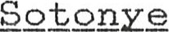 (Gift of God) Margaret Ogan, born February 23, 1974 , in Port Harcourt, Nigeria, Africa.
- . Miabaka (means Thank You) Migbael Ogan , born February 14,
1977 in Dundee, Scotland.

17

1314 . Ruth Marie Horman, born May 7, 1949 . She married Larry Richard, born in 1949, in Moncton, New Brunswick. Ruth has a B.A. from Waterloo Lutheran University in Teacher Training. and a Special Education Training degree from University of British Columbia, with extra courses in psychology, etc . He works for Mitsui in Vancouver, B.C. , sends messages world—wide for them. He had worked for CNR in Moncton before moving west to Vancouver. They live at 393 67 A Street, Delta, B. C. V4L 2B8. Tel. 604) 943-6066. They have adopted two chi Idren .
- . Kathy Horman , born December 1 , 1978 .
- . Keith Horman, born October 29, 1980 .
- . William Edward Horman, born July 31, 1952. He has a degree from Wilfrid Laurier University in Politics and Business Management, and studied at the University of Windsor for his law degree. He is a lawyer practicing in Kitchener, Ontario, is unmarried, and lives at 305 69 Westwood Drive. in Kitchener.
- . Margaret Jean Horman, born May 14, 1955. She has a B e A. in Business Management, is an accountant , and works for West Coast Wool lens in Vancouver , B.C. , Canada. She lives at 3689 West 8th Street, Vancouver, B.C. V6R IY9, Tel. 604) 733-6806.

18
- . Ruth Marie Horman, born May 7 , 1949. She married Larry Richard, born in 1949, in Moncton, New Brunswick. Ruth has a B.A. from Waterloo Lutheran University in Teacher Training. and a Special Education Training degree from University of British Columbia, with extra courses in psychology, etc. He works for Mitsui in Vancouver, B - C . , sends messages world— wide for them. He had worked for CNR in Moncton before moving west to Vancouver. They live at 5349 45th Avenue, Delta, B.C. V4KIK9.
- . William Edward Horman, born July 31, 1952. He has a degree from Wilfrid Laurier University in Politics and Business Management, and studied at the University of Windsor for his law degree. He is a lawyer practicing in Kitchener, Ontario, is unmarried, and lives at 305 69 Westwood Drive. in Kitchener.
- . Margaret Jean Horman, born May 14, 1955 . She has a B.A. in Business Management, is an accountant, and works for West Coast Wool lens in Vancouver, B.C. , Canada . She lives at 1770 Barclay Street, Apt. 1406, Vancouver, B.C. V6G 1K5 .

18
Florence King/John Horman Wedding Party
July 22, 1939
Bridesmaid, Frank King, Jr. , Florence, John, Ethel Pollard
Ethel King/Bill Pollard Wedding Party
July 30, 1938
Bridesmaid, Bill, Ethel, Best Man, Florence King
Ida

Ethel Rose Caroline King, born August 7 , 1916, graduated from Stratford Normal School as an elementary school teacher; on July 30, 1938 at Zion Evangelical Lutheran Church she married William Pollard, born December 24 , 1907 ; Bill was an elementary school teacher at Hamlet School and later the principal at Shakespeare School , Stratford, Ontario . He died on February 5, 1980, and is buried in Brussels Cemetery , Brussels , Ont . They lived most of their life at 27 Youngs Street, Stratford, Ontario N5A 1S5, where Ethel still lives. They had two sons, William and Robert .
1321 . William John Pollard, born November 5 , 1942. On July
4, 1969 he married Nancy Hannay Ross , who was born April 10, 1947. They have four children, two natural Christen and Adam , and two adopted , Alexander and Sonia. He is a school teacher, and they live at 873 Helmuth Avenue, London, Ontario, N6A 3T9 .
13211 . Christen Ross Pollard, born December 1, 1971 in London, Ontario .
- Adam Ross Pollard, born December 10, 1973 in London, Ontario .
- Sonia Rexona Ross Pollard, born May 20 , 1974 in Khulna, Bangladesh.
13214 . Alexander Ross Pollard, born September 18 , 1975 in London, Ontario .
1322. Robert Richard Pollard, born September 7 , 1949 . On October 12 , 1973 he married Elizabeth Anne (Beth) Bradshaw , born July 30, 1951. In 1985 they adopted two children, Tanya and Trevor, who are natural brother and sister. He is a school teacher and they live at 5201 Alton Road, Burlington, Ontario L 7 R 3M9 ,
- . Tanya Elizabeth Pollard, born June 11, 1977 .
- . Trevor Robert Pollard, born September 4, 1979 .

19
Ethel Rose Caroline King, born August 7 , 1916, graduated from Stratford Normal School as an elementary school teacher; on July 30, 1938 at Zion Evangelical Lutheran Church she married William Pollard, born December 24, 1907; Bill was an elementary school teacher at Hamlet School and later the principal at Shakespeare School, Stratford, Ontario. He died on February 5, 1980, and is buried in Avondale Cemetery, Stratford. They lived most of their life at 27 Youngs Street, in Stratford, Ontario where Ethel still lives. They had two sons, William and Robert .
1321 . William John Pollard, born November 5 , 1942. On July 4 ,
1969 he married Nancy Hannay Ross, who was born April 10 ,
1947 . They have four children, two natural — Kristin and Adam, and two adopted , Alexander and Sonya. He is a school teacher, and they live at 873 Helmuth Avenue, London, Ontario, NBA 3 T 9.
1321 1 . Kristin Ross Pollard, born December 1, 1971 in London, Ontario .
13212 . Adam Ross Pollard, born December 10 , 1973 in London, Ontario .
1321.3 . Sonya Rexona Ross Pollard, born May 20, 1974 in Khulna, Bangladesh.
13214 . Alexander Ross Pollard, born September 18 , 1975 in London, Ontario .
1322 . Robert Richard Pollard, born September 7, 1949. On October
12, 1973 he married Elizabeth Anne ( Beth) Bradshaw, born July 30, 1951. In 1985 they adopted two children; Tanya and Trevor, who are natural brother and sister . He is a school teacher and they live at 5201 Alton Road, Burlington, Ontario L 7 R 3M9 .
- . Tanya Elizabeth Pollard, born June 11, 1977 .
- . Trevor Robert Pollard, born September 4, 1979.

19
Frank Edward King, Jr. , born February 4, 1918 at home , 94 Mowatt Street, Stratford; he joined the Canadian Navy in February 1942 and was in Atlantic convoy duty out of Halifax, Boston, New York and St. John' s, Newfoundland where they escorted troop ships by very fast convoys ( except in the case of the liners Queen Elizabeth and Queen Mary which were too fast for any convoy) • After demobilization he went to the University of Toronto and graduated as a Mechanical Engineer . He worked with C. N . Railway first in Stratford and later in Toronto as a M. E. and finally in Montreal as a Research Engineer. On April 25, 1947 he married Hilda May Alderman, born July 24, 1922 at home , 106 Curzon Street, Toronto. Hilda was an accountant.
They had four children, Lois, Janice, Joan and Frank Lawrence ( Larry ) . They are now retired and live at R.R. #2, Lot 19, C8 Vespra, Barrie, Ontario, Canada L4M 4S4.
1331 . Lois Anne King, born November 7 , 1949 , at Toronto General Hospital, married Duncan Allen Bryce Campbell who has an M.S. in Electrical Engineering. She kept her maiden name, is Mrs. Lois King. They live at 50 Pleasant Park Road, Ottawa, Ontario, K2C 2R6 . They have one daughter:
13311 . Sharon Alexandra Campbell, born August 12 , 1984 at Windsor, England, UK.
1332 . Janice Elizabeth King, born April 21, 1951 . She works as a French teacher. On May 10 , 1976 she married Richard Wayne Woods, born July 23, 1950 at Toronto. He is a Postmaster and they live at 42 Brennan road, Ajax, Ontario, Canada LITIK2. They have two daughters :
13321 . Andria Michelle Woods, born September 13, 1980, at St . Michael's Hospital, Toronto, Ontario.
13322. Allison Valerie Woods , born February 10 , 1986, at
Toronto .

20

133 . Frank Edward King, Jr. , born February 4, 1918 at home, 94 Mowatt Street, Stratford; he joined the Canadian Navy in February 1942 and was in Atlantic convoy duty out of Halifax, Boston, New York and St. John' s, Newfoundland where they escorted troop ships by very fast convoys (except in the case of the liners Queen Elizabeth and Queen Mary which were too fast for any convoy) . After demobilization he went to the University of Toronto and graduated as a Mechanical Engineer. He worked with C. N. Railway first in Stratford and later in Toronto as a
M. E. and finally in Montreal as a Research Engineer. On
April 25, 1947 he married Hilda May Alderman, born July 24, 1922 at home, 106 Curzon Street, Toronto. Hilda was an accountant . They had four children, Lois, Janice , Joan and Frank Lawrence (Larry) . They are now retired and live at R.R. #2, Lot 19, Cd Vespra, Barrie, Ontario, Canada L4M 4S4 .
1331 . Lois Anne King, born November 7 , 1949, at Toronto General
Hospital, married Duncan Allen Bryce Campbell who has an M.S. in Electrical Engineering. She kept her maiden name, is Mrs. Lois King. They live at 611 Kensington Drive, in Chapel Hill, North Carolina, USA, 27511 . have one daughter:
13311 . Sharon Alexandra Campbell, born August 12, 1984 at Windsor, England, UK.
1332 . Janice Elizabeth King, born April 21, 1951 . She works as a French teacher. On May 10, 1976 she married Richard Wayne Woods, born July 23, 1950 at Toronto. He is a Postmaster and they live at 42 Brennan road, Ajax, Ontario, Canada LITIK2. They have two daughters :
- . Andria Michelle Woods, born September 13, 1980, at St. Michael's Hospital, Toronto, Ontario.
- . Allison Valerie Woods, born February 10 , 1986 , at Toronto .

20
1333 . Joan Hilda King, born July 17, 1954 at Royal Victoria Hospital, Montreal, PQ. She works as a computer specialist at C.F. C.F. TV/Radio Station. On August 22, 1981 at McGill University Chapel, Montreal, she married Robert Daniel Yacovitch, born December 9, 1950 at Queen Elizabeth Hospital, Montreal; he has a PhD in English and Physics . They live at 527 Montcalm St. in Doll ard Des Ormeaux, PQ H9G 1K6. (Montreal Island) . They have two children:
13331 . Tara Irene Yacovitch , born October 16 , 1984 , in Montreal .
13332. James Ivan Yacovitch, born June 1 , 1987
1334 . Frank Lawrence (Larry) King, born August 23, 1958 . He is single, works as an electronic technologist at Bell Telephone in Ottawa. He lives at 1124 Lazard Street , Ottawa, Ontario K2C 2R6 .

21
Melvin King
OTTAWA Melvin Albert
King, 67, of Ottawa, formerly of Guelph, died Tuesday in Ottawa.
Born in Stratford son of the late Frank King and Ida Wilhelm, he taught at the University of Guelph for many years, retiring in 1974.
He was predeceased by his first wife, Adelaide McGill, in 1974.
Mr. King is survived by his wife, Huguette; one son James, of Kingston; two daughters, Rosemary and her husband, Rev. Keith Lewis, of Putnam, and Carolyn, of Edmonton; two grandchildren, Jasmine and Jennifer Lewis; two brothers, Frank of Barrie and Carl of Fort Erie; and two sisters, Florence Horman, of Waterloo and Ethel Pollard, of 27 Youngs St., Strat ford.
The funeral service will be held Friday in Ottawa.
134 . Melvin Albert King, born August 8, 1920 , died December 1 , 1987 of heart problems; buried in or near Ottawa,
Ontario . He was married ( 1 ) to Adelaide Paterson McGill, born July 28, 1922; she died on July 13, 1974 from cancer . Melvin served in the Canadian Army Intelligence Corps. during WWII, and after the war he taught German and French at Ontario Agricultural College (now the University of Guelph) , where he was later an Associate Professor of English. Adelaide was a high school teacher of Physical Education and Latin at Guelph Collegiate-Vocational Institute in Guelph from 1947-1974. They had three children. He remarried to Hugette ( ) in 1980, and they lived at 41 Woodridge Crescent, Apt. 613, Nepean, Ontario, Canada K2B 7T6.
1341 . Margaret Rosemar.v King, born April 9, 1951 in Guelph,
Ontario . She married Rev. Keith Lewis, born August 18, 1946, a United Church minister who recently transferred from Nova Scotia where he had a 4 -parish pastorate to the London area where he again has a 4-church pastorate for the United Church called Avon—Putnam. Their address is Box 3 , Putnam, Ontario , Canada NOL 2BO. They adopted two children :
- . Jasmine Lewis, born March 13, 1982 .
- . Jennifer Lewis, born February 23, 1985 .
- . James Melvin ( Jim) King, born August 31, 1953. He is working on his Masters in Engineering at McGill Univer— sity in Kingston. He lives at 186 University Avenue, Kingston, Ontario, Canada, K 7 L 3P4 .
- . Caroline Ruth (Carly) King, born June 8 , 1955 . She works as a Research Officer, and lives at 10712 University Avenue, Apt. 106, Edmonton, Alberta, Canada , T6E 4P9 .

22
135 . Carl Robert King, born November 10, 1931, married ( 1 ) Pauline Jolley, born December 16, 1941. Carl works as a machinist for CNR. From this marriage there were 3 chi Ldren :
1351 . Stephen John King, born September 15, 1958. On May 17 , 1986 he married Diana Edwards, born August 17 , 1954 . Stephen has a degree in Kinesiology from the University of Waterloo , and he teaches Physical Education and Science at Carleton Place, Ontario; Diana also teaches in the same county . They live at 23 Henderson Street , Carleton Place, Ontario, K7 C 3 Zl (613) 257-3739 , and they have one son.
13511 . Trevor James King, born August 28, 1988 at Smith Falls Community Hospital, 6 lbs. 10—3/4 oz.
- . David Carl King, born May 26, 1960. On December 27 , 1986 he married Nancy Cook, born April 12 , 1963 . He studied biology at the University of Waterloo , graduated Spring 1986 with a B. Sc. in Biology, majoring in Molecular Biology. David had a scholarship and a teaching position for the 1986-87 year; he now has his teaching degree and is currently looking for a High School Science teaching position.
- . Sharon Rose King, born September 29 , 1967 . She is currently attending the University of Western Ontario , entering her 3rd year in honours physical education program. She is interested in teaching as well.
Carl and Pauline were divorced and he remarried, ( 2 ) Bonnie Roy Krabinsky ( ? ) on Easter Monday, 1985. They live at 214 Phipps Street, Fort Erie, Ontario, Canada , L2A 2V5.
*Carl King ' s information provided by Florence King Horman and Stephen & Diana King .

23
WILHELM - R.R. TAVISTOCK, ONTARIO
14 . Theodore Robert Wilhelm was born on May 7 , 1891, and died
May 30, 1977 in Lakeland, Florida. He is buried at Trinity Lutheran Cemetery, Sebastopol, Ontario. He was married ( 1 ) on June 30, 1915 in Zion Evangelical Lutheran Church, Strat— ford to Flora Anna Martha Krug, born June 21 , 1891; she died on February 11, 1962, and is buried at Trinity Cemetery, in Sebastopol They lived early in their marriage in Stratford and later moved to East Zorra township where they were lifelong farmers in East Zorra Twp. where they had a large milk cattle herd and chicken business. From this marriage there were f i ve surviving children: George, Gladys, Edith, Edna, and Harold.
Below is a photograph of the June 30, 1915 wedding of
Ted and Flora, with attendants George and Clara Wilker .
Ted married ( 2 ) Jane "Jennie 'i Watson, in May 1964. She was born in Dreham County, England, daughter of Mr. & Mrs . Joseph Watson. Married ( 1 ) to Henry Robbins. She died on July 29, 1967.
141 . George Rheinhart Wilhelm, born April 16, 1916 at their Front Street residence, Stratford, Ontario. On February 18, 1939 at United Church parsonage in Hickson he was married to Lenore Olive McGregor, born May 30, 1916 at Lot 26, Conc. 11, East Zorra Township. They have farmed all their lives on their farm, "Brenelm Farms, Ltd. 1 1 in East Zorra Twp. From this marriage there were six children: Arlene, Kenneth, Sandra, Linda, Jane and Brian . Their address is R.R. #2, T avis tock, Ontario, Canada NOB 2RO.

25
Below is a picture of the George Wilhelm family.
Standing - Ken, Brian, George, Arlene Seated in Chairs - Linda and Lenore Seated on Floor - Jane and Sandra
25a

1411 . Arlene Lenore Wilhelm, born October 5, 1939 at 29, Conc. 10 East Zorra Twp. She was married on November 15 , 1958 to Robert Norman Wettlaufer, born September 13 , 1938 at Lot 27, Conc. 10, East Zorra Twp. They f arm ; address R.R. #2 Tavistock, Ontario. They have four children: Wayne, Kenneth, Kathryn and Jeffrey .
14111 . Wayne Robert Wettlaufer, born April 11 , 1961 at Stratford General Hospital. Married August 15 , 1981 to Patricia Anne Gaynor, born August 3, 1958 , at Grace United Church, Tavistock, Ontario. He works on farm machinery and is a diesel mechanic. They have two chi Ldren :
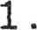 Adam Wayne Robert Wettlaufer, born October 8, 1983 at Stratford General Hospital.
141112 . Darryl Patrick William Wettlaufer, born January 29 , 1986 at Stratford General Hospital.
14112 . Kenneth William Wettlaufer, born May 11 , 1962. Married July 30, 1983 at Grace United Church, Tavistock, to Susan Lorraine Lupton, born June 14, 1965 . He is a cabinet maker and maker of custom furniture . They have one son.
141121 . Matthew Kenneth Wettlaufer, born May 25, 1987 .
14113 . Kathryn Ann Wettlaufer, born May 27 , 1967 at Stratford
General Hospital .
Jeffrey John Wettlaufer, born August 18, 1971 at Strat— ford General Hospital .
Present address of all children is R.R. #2 Tavistock, Ontario, NOB2RO .

26
1412 . Kenneth George Wilhelm, was born March 16, 1941, at 28, Concession 12, East Zorra Twp. Married April 6, 1963 at Knox Presbyterian Church, in Harrington, Ontario to Phyllis Elizabeth Lupton, born July 3, 1943, and presently resides at R. R. #2 T avis tock, Ontario, NOB 2R0, where they farm. In 1984 Ken and his son Jim bought the company, ^{I l} Brenelm Farms, Ltd. from George and Lenore . They have four children: James, Nancy, Steven and Mark.
- . James Kenneth Wilhelm, born October 8, 1963 at Stratford General Hospital . He farms with his dad on ^{I l} Brenelm Farms , Ltd. ^{i} ' and is a graduate in farm management and production.
- . Nancy Elaine Wilhelm, born September 21, 1964 at Stratford General Hospital . Nancy is now a graduate in bus 1 ness administration, and works in marketing. She lives in Toronto, Ontario .
- . Steven Ronald Wilhelm, born March 28, 1968, at Strat-ford • General Hospital . He is a university student .
Mark Douglas George Wilhelm, born June 16, 1971 at Stratford General Hospital .
All children reside at home , R.R. #2, Tavistock , Ontario, except Nancy, in Toronto .

27
1413 . Sandra Edna Wilhelm, born November 24, 1943 at 31 ,
Concession 11, East Zorra Twp. Married May 3 , 1963 at United Church parsonage, Hickson, Ontario to William
Floyd Kalbfleisch, born July 13, 1944 at Kitchener— Waterloo Hospital . Present address is Hickson , Ontario, NOJ ILO. Bill at one time had a band, enjoyed singing, and he was a transport driver; he suffered from Muscular Sclerosis, died May 8, 1988, just after their 25th anniversary. Sandra is a hair stylist.
They have three children :
- . Karen Marie Kalbfleisch, born October 25, 1963 at
Stratford General Hospital . She is an aesthetician.
- . Paul William Kalbfleisch, born November 16, 1964 at Stratford General Hospital . He is a truck driver.
- . Tammy Lynn Kalbfleisch, born August 11, 1969 at Strat— ford General Hospital .
All children presently reside at home, Hickson, Ontario NOJ ILO.

28
1414 . Linda Violet Wilhelm, was born May 7 , 1947 at 31, Conces— sion 11, East Zorra Twp. On June 14, 1968 at Trinity Luthe— ran Church, Sebastopol she was married to John Vernon Killing, born April 26, 1946 at Stratford General Hospital . Presently reside at R.R. #6, Woodstock Ontario, N4S 7 WI . He is a clerk and treasurer of East Zorra—Tavistock Twp, and Linda is a secretary. They have three children:
14141 . Kari Lynne Killing, born January 26, 1970 at Stratford General Hospital .
Kent William Killing, born July 18, 1972 , at Stratford General Hospital .
1414•3 . Suzanne Marie Killing, born November 5, 1974 at Strat— ford General Hospital .
All children reside at home, R.R. #6, Woodstock Ontario, N4S 7W1.

29

1415 . Jane Ann Wilhelm, born January 30, 1952 at Stratford General Hospital . She was married August 1 , 1969 at Trinity Lutheran
Church, Sebastopol, to Steven Clayton Bender, born September 4, 1950 at Stratford General Hospital. They presently re— side at 31 Homewood Avenue, T avis tock, Ontario NOB2RO . Steve works in sales of pre—cast concrete, and Jane is an accounting clerk. They have two children:
14151 . Robert Steven Bender , born October 28, 1969 , at Stratford General Hospital.
1414 2 . Angela Jane Bender, born November 12, 1972 at Stratford
General Hospital .
Both children reside at home,
31 Homewood Avenue, T avis tock NOB 2R0 .
30
1416 . Brian Harold Wilhelm, born December 23, 1956, at Stratford General Hospital. He was married on October 8 , 1976 at Trinity Lutheran Church, Sebastopol, to Joanne Marie Beynon, born April 6, 1955 at Newmarket Hospital, Newmarket, Ontario . Brian is a real estate broker. They have three children :
- . Barbara Ann Wilhelm, born January 20 , 1979 at Stratford General Hospital.
- . Christine Lynn Wilhelm, born August 26, 1980 at Stratford General Hospital .
- . Debra Jane Wilhelm, born April 26, 1984 at Stratford
General Hospital .
Present family address is R.R. #5, Embro , Ontario NDJ 1 JD .

31
142 . Gladys Ella Wilhelm, born February 15, 1918 in East Zorra Township. On March 5 , 1941 at Trinity Lutheran Church parsonage, Sebastopol, she was married to Gordon McGregor, born May 3 , 1914. Gordon Lives today at Argle Street, Embro, Ontario, NOJ IJO, and Gladys is a resident of the People Care Center in Tavistock, Ontario, NOB 2R0 . They had two daughters :
1421 . Donna Marie McGregor, born May 6 , 1942 in East Zorra
Township. On July 7 , 1958 at Knox United Church Manse,
Embro she married Ronald Clifford Rudy, born March 16, 1939. They presently live at 31 Holley Avenue , T avi— stock, Ontario, NOB 2RO . They have four children :
14211 . Deborah Marie Rudy, born September 28, 1958. On July
15, 1983 she married Murray George Paton, born August
31 , 1954, at St. David' s United Church, Woodstock, Ontario . They currently reside at 1132 Mohawk Street, Woodstock, Ontario, and have two sons ,
142111 . Geoffrey Ronald Kenneth Paton, born March 26, 1986 .
142112. Kelly Marie Paton, born April 16, 1988 .
- Jeffrey Ronald Rudy, born December 14, 1960 . At home .
- Karen Ann Rudy , born February 5, 1963, is a Registered Nurse ; she was married November 1 , 1986 to James Lyle Tuffnail , born April 25, 1964. They reside at 163 William Street, Tavistock, Ontario, NOB 2R0 .
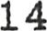214 . Tracey Lynne Rudy , born August 18, 1971 . At home .

32
1422 . Joyce Edith McGregor, born June 4, 1945; she was married on September 5, 1964 at United Church Manse, Embro, Ontario, to Donald D. G. Wilker, born December 30, 1941. Their pre— sent address is 468 Highland Road, Woodstock, Ontario N4S 5W8 . They have three children :
- . David Michael Wilker, born September 20, 1965 at Woodstock General Hospital. At home .
- . Steven Donald Wilker, born October 28, 1968 at Woodstock General Hospital.
- . Lori Ellen Wilker, Born November 4 , 1970 at Woodstock
General Hospital.
Children all reside at home.

33
14 3 . Edith Clara Wilhelm, was born October 23, 1919; she was married December 4, 1948 at Trinity Lutheran Church, Sebastopol, to Newton Oswald Bean, born February 10, 1920; he is a farmer. They reside and farm at R.R. 5 , Embro, Ontario, NOJ IJO and have 4 children: Robert, Clare, Susan and Bruce. Below is a picture taken following their wedding.
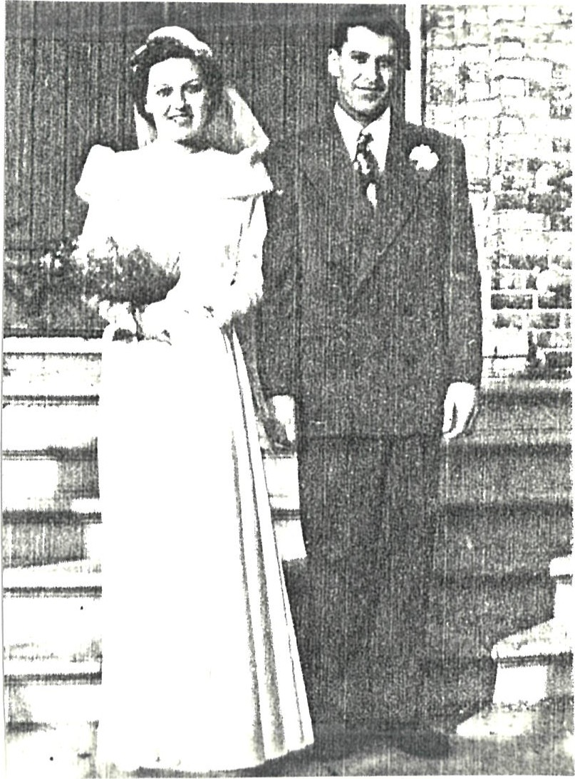
Edith and Newton Bean,
December 4, 1948
1431 . Robert Allan Bean, born September 3, 1949, married March
18, 1972 in Harrington United Church -to Joan Isabel Innes, Born October 21 , 1949 . He is a teacher and farmer. They reside at R.R. 2, Embro, Ontario, and have 3 children:
1431 1 . Darren Robert Bean, born May 2, 1974 .
- . Jeffrey Scott Bean, born January 31, 1977 .
- . Melissa Joan Bean, born August 2, 1982 .

34
14 •3 Edith Clara Wilhelm, was born October 2 .3 , 1919; she was married December 4, 1948 at Trinity Lutheran Church, Sebas— topol, to Newton Oswald Bean, born February 10, 1920; he is a farmer. They have retired, (Newton still helps Bruce on his farm) and live at R.R. 5 , Embro, Ontario, NOJ IJO; they have 4 children: Robert, Clare, Susan and Bruce . Below is a picture taken following their wedding.
Edith and Newton Bean,
December 4 , 1948
1431 . Robert Allan Bean, born September 3, 1949, married March
18, 1972 in Harrington United Church to Joan Isabel Innes, Born October 21 , 1949 . He is an Industrial Arts teacher and farmer. They reside at R.R. 5, Embro, Ontario, NOJ 1 JO , and they have 3 children:
- . Darren Robert Bean, born May 2, 1974.
- . Jeffrey Scott Bean, born January 31 , 1977 .
1431.3 . Melissa Joan Bean, born August 2, 1982 .

- . Clare Willis Bean, born May 7 , 1951. He is with CoOp
Insurance in the Loss Prevention Branch and does some Underwriting as well. He lives at 198 Bradford Avenue, Ottawa, Ontario. He is presently unmarried.
- . Susan Lynda Bean, born March 28, 1955. She was married at Brooksdale United Church on May 19, 1979 to John Charles Garner , born October 24, 1952. Susan in an R.N. and he is a dairy farmer. They reside at R.R. 1 , Embro , Ontario , and they have one son.
14331 . Kurtis Charles Garner , born September 15 , 1986 at
Stratford General Hospital .
'3 4 . Bruce George Bean, born March 31 , 1957; on December 10 , 1983 at Grace United Church, T avis tock he was married to Joanne Olive Weicker, born December 2, 1958 . He is a dairy farmer and they live at R.R. 5, Embro, Ontario, NOJ 1 JO They have two children:
14 3 4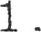Travis John Bean, born May 21 , 1984 .
Tovah Marie Bean, born September 14 , 1986 .
4 . Edna Florence Wilhelm, was born September 8, 1921, and married on November 30, 1946 at Trinity Lutheran Manse, Sebastopol to John Alexander McKay, born October 9, 1918 at Lot 28, Conc. 11 East Zorra Twp. They had four children: Rosanne, James, Larry and Keith. John and Edna own large acreage in East Zorra Twp. and their sons Jim and Larry also own/ and or rent 1000 acres on which they grow corn, and have a hog and beef operation. They live at R.R. #6, Woodstock, Ontario, Canada N4S 7 WI . A picture taken after their wedding is below - Harvey McKay, John McKay, Edna, Edith
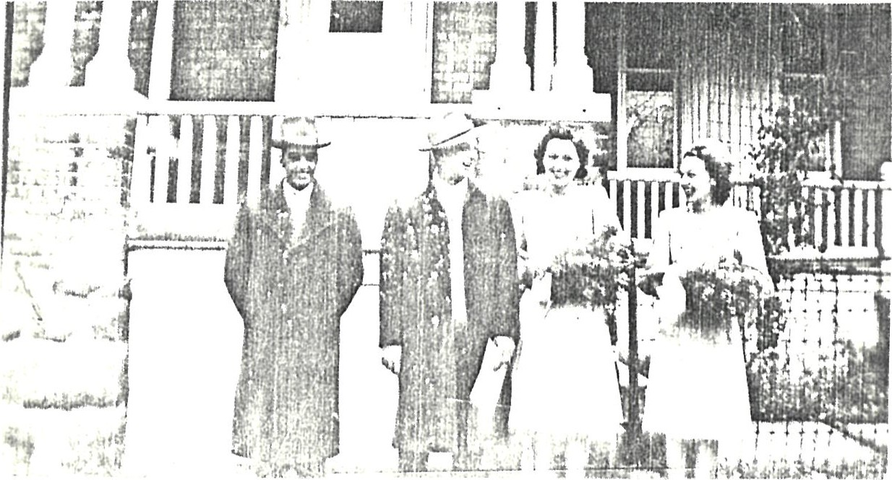
14 41 . Rosanne Florence McKay, born September 30, 1947 at Stratford
General Hospital . She was married on September 26, 1969 at Trinity Lutheran Church, Sebastopol, to Roger Milton Bender, born August 7, 1945. They have three children, and reside at R.R. #1, Tavistock, On-bario NOB 2RO.
14411 Daryl Roger Bender, born May 13, 1972 at Stratford General Hospital .
14 412 . Tricia Anne Bender, born February 5 , 1978 at Stratford General Hospital .
14 413 . Leanne Jane Bender, born January 11, 1981 at Stratford
General Hospital .
4 2 . James Franklin McKay, born February 2, 1952 at Stratford General Hospital. At home, unmarried.
14 4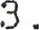Larry John McKay, born May 3 , 1956 at Stratford General Hospital . On June 20, 1986 at Trinity Lutheran Church ,
Sebastopol, he married Patricia Ann (Patti) Brunk, born November 3, 1960 . They are living at R.R. Woodstock, Ontario N4S 7 WI.
1444 . Keith Allan McKay, born September 25, 1957 at Stratford General Hospital. Married at Trinity Lutheran Church,
Sebastopol on January 29, 1977 to Tanya Fern Quehl, born October 21, 1958 at Stratford General Hospital . They have two children. They live at 49— 14th Street, Tavistock, Ontario, NOB 2RO.
14 4 41 . Jill Alicia McKay, born April 1 , 1977 at St. Joseph' s
Hospital, London, Ontario.

145 . Harold Fleming Wilhelm, was born January 7 , 1926. He was married on June 18, 1949 at T avis tock Evangelical Church, to Lyla Her lick, born November 25, 1928. They have six children: Harry and Lyla live on the family homestead, R.R. #2, T avis tock, NOB 2R0 (Ted's farm) which they bought from his father, and they still farm there . Below is a picture of their family taken on Christmas Day 1984 .
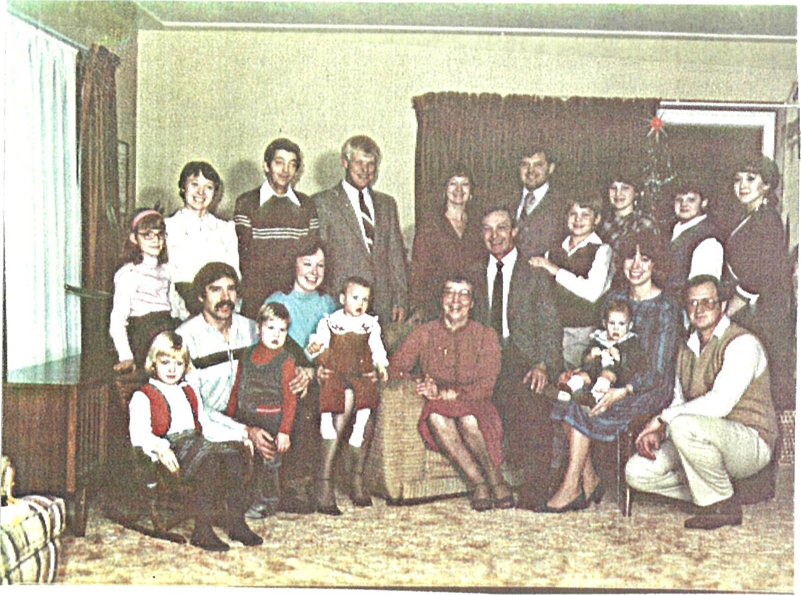
1451 . Carolyn Ruth April 12, 1950 at Stratford
General Hospital . On September 21 , 1973 at Trinity Lutheran Church, Sebastopol, she married Leonard Wilker, born April 10 , 194.3 . They presently live at 135 Greendale Crescent, Kitchener, Ontario, and they have three children :
- . Adrienne Marie Wilker, born April 21, 1976 .
- . Laura Kristine Wilker, born February 27 1979 .
- . Sarah Margaret Wilker, born September 11, 1985 .
Mary Lee July 25, 1951 at Stratford General Hospital. Married at Trinity Lutheran Church, Sebastopol , to Murray Junker, born September 1 , 1947 . They presently live at R.R. Tavist,ock, Ontari.o, NOB 2RD, and they have three children:
- . Ann Marie Junker, born August 17 , 1971 .
- . Tara Lee Junker, born August 17, 1972
- . James Harold Junker, born July 13, 1974 .

41
1453 . Bonnie Elaine at Stratford General Hospital cn
July 25, 1953. Married at home at Lot 29, Conc. 10 East
Zorra Twp. on July 17, 1981 to David Hallman, born June 2, 1954 , Their present address is R.R. #2, Tavistock, Ontario, NOB 2RO. They have two children :
145.31 . Drew David Hallman, born February 28 , 1982 .
14 5.32 . Paige Elaine Hallman, born December 21 , 1983 .

42

1 4 54 .
4 E) 41 .
14542
14543 .
Joan Ann at Stratford General Hospital on May
25 , 1958 . On November 18, 1978 at Trinity Lutheran Church,
Sebastopol, she married Ronald Ferguson, born April 20 , 1957 . They presently live at 51 Decew Street, T avis tock, Ontario, NOB 2RO, and have three children:
Jay Ronald Ferguson, born February 2 , 1984 .
Kendra Ann Ferguson, born February 6 , 1986 , and her twin
Daniel Robert Ferguson, born February 6, 1986 .

- . Kim Elizabeth Wilhelm, born at Stratford General
Hospital on June 15, 1963. She is to be married August 13, 1988 to Rocco Urlando, at Trinity Lutheran Church, Sebastopol, Ontario .
- . Wayne Harold Theodore, born March 1, 1966 at Victoria
Hospital, London, Ontario. He is single, at home .
MINNA ANNA WILHELM KUDOB STRATFORD, ONTARIO
15 . Minna Anna Marie Wilhelm, born March 29, 1893, died May 2, 1982 , age 89 . She is buried at Avondale Cemetery, Strat— ford, Ontario. Married 1 ) 14 June 1916 in Zion Evangelical Lutheran Church, Stratford, to George Edwin Nahrgang, born March 15, 1891 in Wilmot Township, Waterloo County; he died of diabetes on 10 June 1920 in Hamilton, Ontario, and is buried at New Hamburg. Minnie married 2 ) Frank Dickson, born died at age 3.3 ; he is buried in Dundas, Ontario- They had one son:
151 . Allan Franklin Dickson, born May 7 , 1929 at Dundas, Ontario . He married Lois McCallum, from Little Lakes, born
They adopted a daughter and then had one of their own. Allan worked for Bell Canada, and he died of a heart attack on November 3, 1974 and is buried in the Mennonite Cemetery, T avis tock, Ontario (East Zorra Township) .
- . Virginia Belle Dickson, adopted; born
- . Jennifer Fath (Faith?) Dickson, born
Lois remarried after Allan's death, is now Lois Filsinger. They lived on a farm at Ayton, Ontario, recently moved to Kitchener, Ontario.
Minna married 3) on December 5, 1931 at the Zion Parsonage to Godfried (Fred) Kudob, born February 19, 1876 in Germany, came to Canada at age 4 years, and he died on August 8, 1956 . He is buried at Avondale Cemetery, Stratford, Ontario . They had one daughter. Below is a very light picture of Minnie taken in the early 40' s, and a group picture showing Fred, Minnie, waiter, Emma, Flora and Ted taken on a Great Lakes Cruise in the early 50' s. It is also very light, but it's all I have with Minnie in the picture.
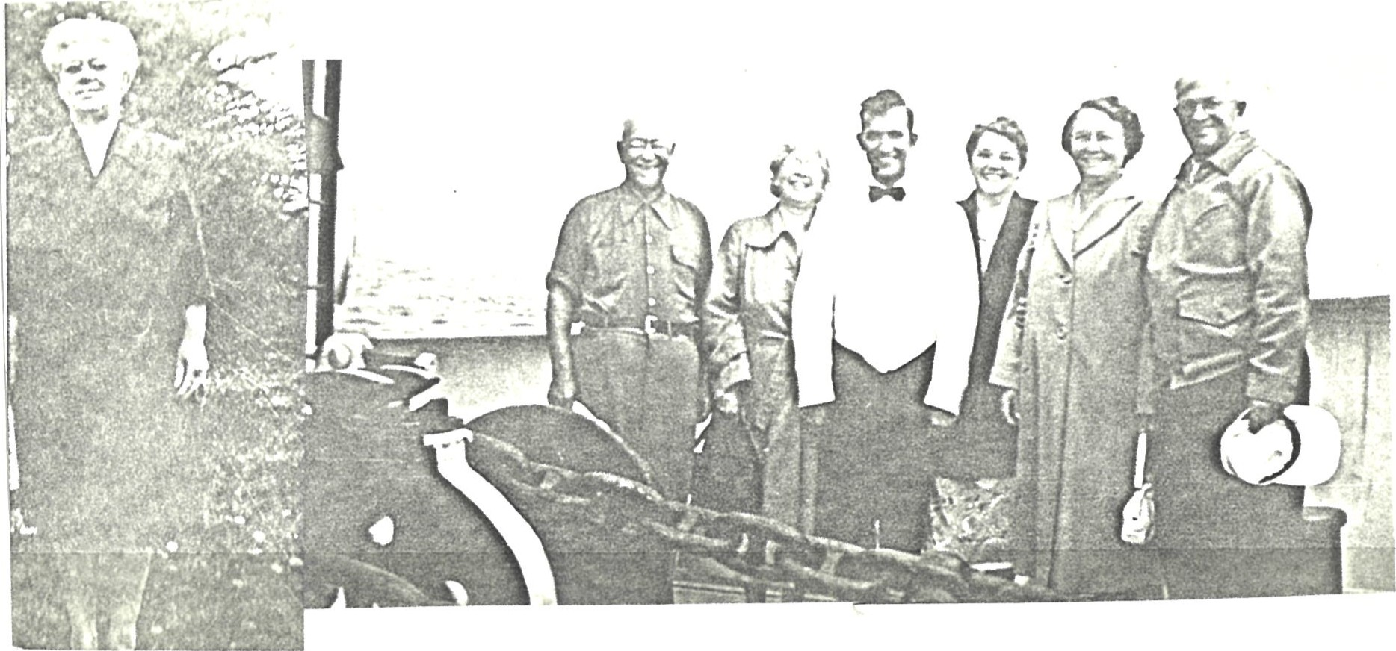

45

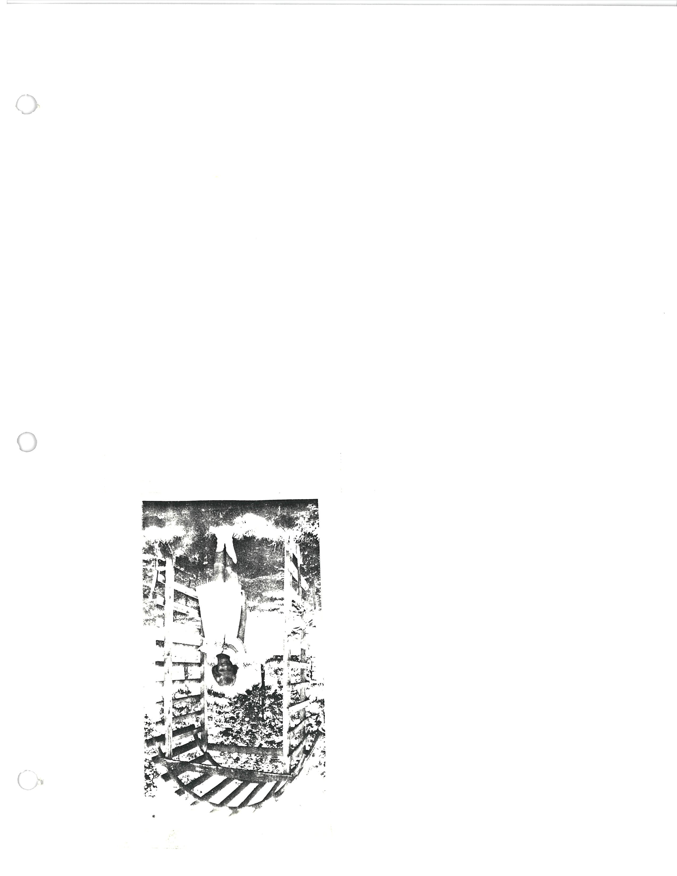

152 . Eileen Rose Kudob, born September 29, 1932, and married on
July 25, 1953 at Zion Evangelical Lutheran Church to Robert Skirten, born December 26, 1931 at Stratford General Hospi— tam. Eileen had worked as an accountant before the family came; some years ago she had a near—fatal reaction to self— administered medication for asthma. Her recovery took many months in hospital and years at home. Bob works as a machin is t, and they now live at R.R. Goderich, Ontario, N 7 A 3Y.3 . They had three sons, and adopted a daughter. Again, two small cut-out pictures showing Eileen during the late 40' s or early 50's one also has Margaret Heideman ( a cousin) and Bette Wilhelm — dressed for some game at, a reunion .
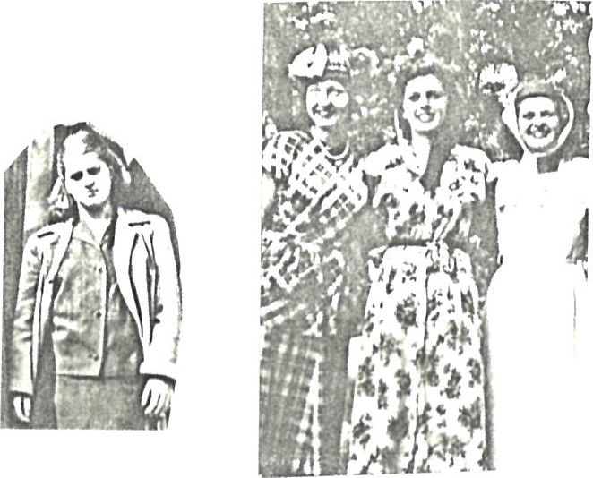
1521 . Robert Skirten, born May 29, 1954 . He married Joan McTavish. They had two S ons, are now divorced.
- . Bradley Robert Skirten, born August 26, 1974, at Stratford General Hospital.
- Matthew Stuart Skirten , born June 15, 1977 , at Stratford General Hospital.
1522 . Allan Paul Skirten, born December 17 , 1959 , at Stratford General Hospital . He is single, works at restoring aircraft . He lives at home.
152.3 . Bruce Eric Skirten, born December 29, 1961 at Stratford General Hospital. On October 19, 1985 he married Victoria Powell, born July 16, 1961. He is a carpenter.
1524 . Kristine Roseanne Skirten, adopted, born January 10, 1968 at Toronto General Hospital, Toronto . She lives at home .
WALTER FREDERICK WILLIAMS FLINT, MICHIGAN
16 . Walter Frederick (Wilhelm) Williams, born March 30, 1895 in Baden, Ontario, died July 14, 1962 following a cerebral hemmorhage, in Flint, Michigan where he Lived with his wife Bessie Irene Bittner, whom he married on May 11, 1918 . was born December 15, 1899, and died April 22, 1975. They are buried at Sunset Hills Cemetery, Flint, Michigan. Before moving to the States Walter worked for a short time for the Grand Trunk Railway in Stratford, then moved to Michigan where he worked for the City of Flint as a machi— n i st, and later for the Chevrolet Division of General Motors in Flint, first as a machinist and later teaching his trade at General Motors . In WWI he was a Cpl. in the U.S. Army Ordnance Corps . They had two sons, and lost a daughter at bi rth.
Below and on the following page are several photographs, one of Walt and Bess, and some of the boys with their parents.
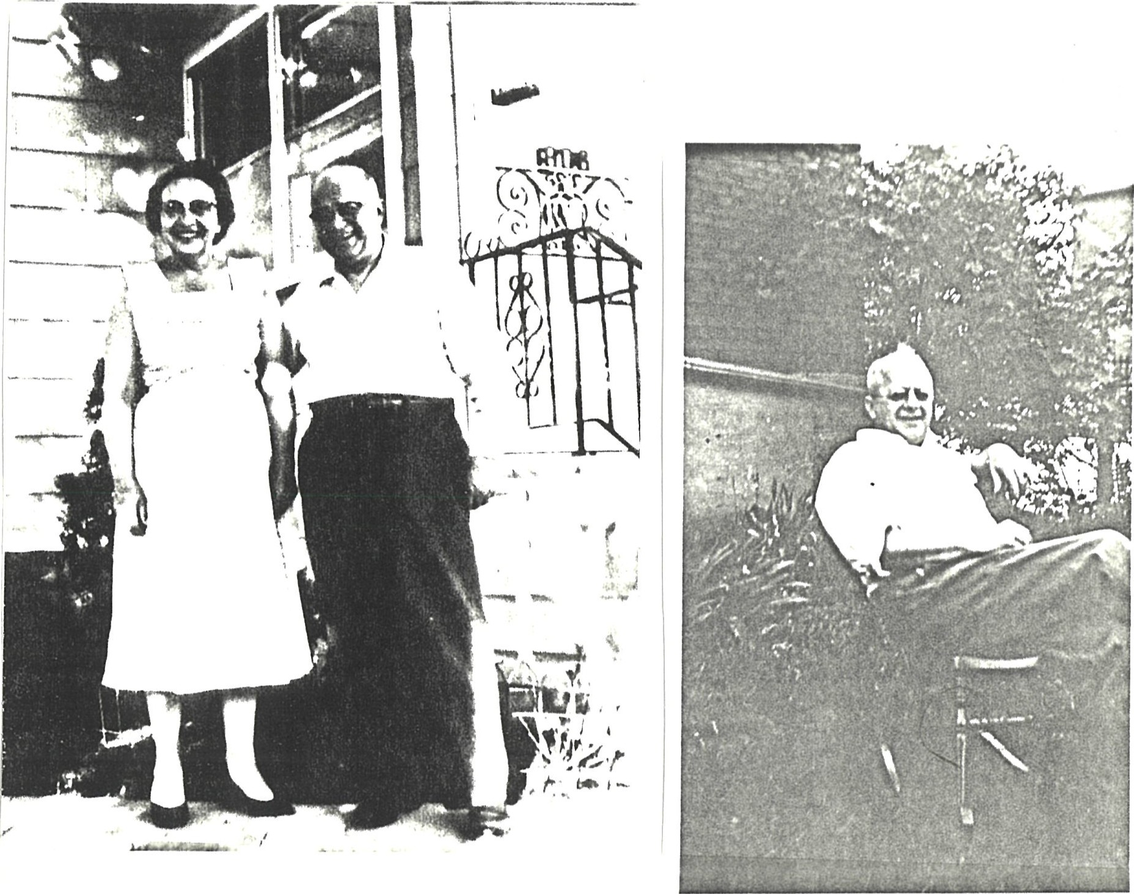
マを第、い
、を
第ツ付。ツ
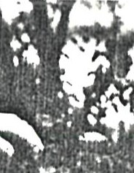
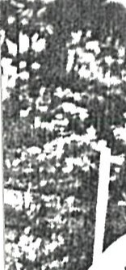 ・り、い
 | " ,三上ツ |   第 第

161 . Donald Allen March 21 , 1920 in Flint, MI. ,
On June 23, 1941 he married Katherine 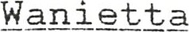 Gage, born
April 12, 1924. They had one son, and were later divorced. Donald served in the US Marine Corps during WWII; after the war he worked as a butcher for a Bazley Markets grocery chain, then later operated his own butcher shop. After that he worked for Buick Division of GM. He divorced and remar— ried in 1953 to Dorothy K Iida, born April 7 , 1925, and they had five children. Don was severely burned in a brush— burning accident at home in the 70' s. He is now retired, and they live at 1524 S. Huron Road, in Tawas, Michigan. He did not respond to my request for information.
1611 . Donald Robert Williams, born April 9, 1943. On August 8, 1964 he married Mary Ann Achatz, born August 11, 1945, and they had four sons. They lived in St. Clair, MI. He was an electrician and was electrocuted at work on June 20 , 1980. Mary Ann remarried on May 10, 1986, to Charles Bell, but she keeps the Williams name, Mary Ann Williams Bell, and they live inn Ortonville, MI, a suburb of Flint .
16111 . Dawn Marie Williams, born January 4, 1965 . She married Scott Hayward, born January 4, 1965 . They have one son, and are expecting a second child August 14, 1986 to be delivered by Caesarian section.
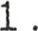 Teddy (not Theodore) Robert Hayward, born June 11, 1985 .
161112 . Hayward , born August 14 , 1986 .
- . Michael Anthony Williams , born December 22, 1966 . He is married to Eileen
- . Matthew Walter Williams , born November 10, 1967 . He works in Detroit.
- . Dean Robert Williams , born September 22, 1968 . He at home .
Don' s second family, with Dorothy, follows :

- . Deborah Williams, born August 7, 1953. lives at, home .
- . Douglas Williams, born May 31 , 1955 in Flint, MI . He was married in May 1986 to Cathy Green (Kathy Greene?) , and they live in Lapeer, Michi gan. He works as
- . Den i s e Williams, born May 24, 1956. She is married, no further details. Believe they have children.
- . Diane Williams , born July 31 , 195B .
1 61 6 . David Williams, born May 3, 1960 .
*This is all the information available on Don' s families, obtained from Marcia and Bob Williams as Don did not respond to my request.
- . Baby girl, prematurely born October 24, 1921 , as the result of a fall Bessie had.
- . Robert Oscar September 2, 1922 in Flint,
Michigan. On October 29, 1949 at 1st Presbyterian Church in
Flint, MI he married Marcia Sandi lands Gray, born February 18, 1920, also in Flint - though they had lived only 6 or 7 blocks apart for years they didn't meet until 1944. Marcia and Bob have two children. Since 1972 Bob and son Robert have operated their own mechanical thermal insulation business, T ICON, doing industrial and commercial HVAC work, and Bob . (older! ) has several US Patents to aid the thermal insulation business. Bob and Marcia live on the old 80 —acre Bittner farm, which they purchased from his grandmother following grandpa Bittner' s death, and they have entirely remodeled what was once a primitive salt—box with lean—to" dwelling to a modern ranch style home at 2264 Weber Road, Gladwin, Michigan, USA 48624. Tel. ( 517 ) 426-9932 .
Below is a family picture taken in March, 1983
Rear — Bob A. , Bob O. , Marcia, Terry Cameron
Front Barbara holding Erin, Sue holding Ryan
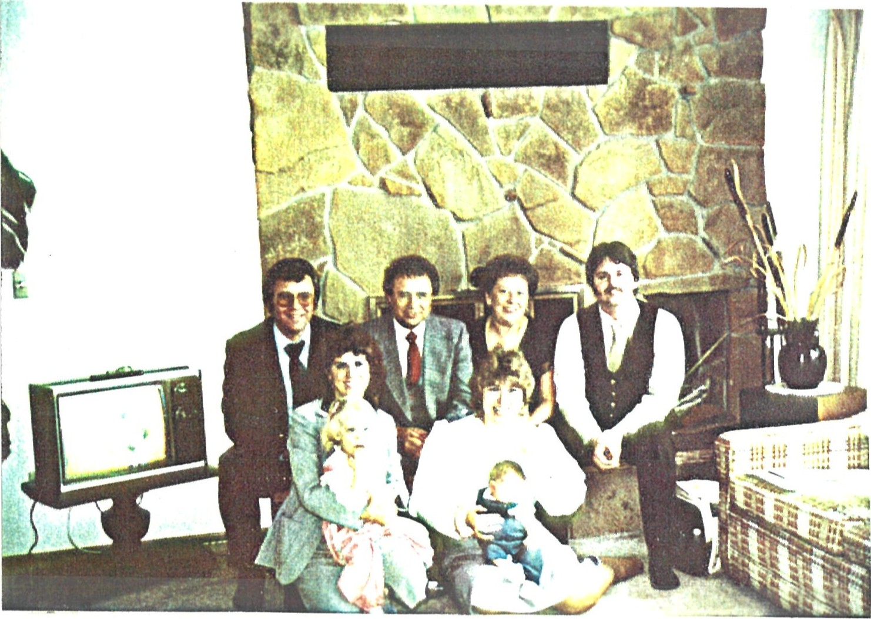

1631 . Robert Andrew ( Bob "A 'i ) March 23, 1951 at Hurley Hospital, Flint. He has a B.A. in accounting from Central Michigan University ( 1973) , and he is a Capt . in the Army Reserve. He was married on August 10 , 1974 at 1st United Methodist Church, Gladwin, to Barbara Jean Rellinger, born July 13, 1951. She has her degree from CMU and taught Childhood Development and Marriage for 7—1/2 years, and is now a substitute teacher. He is the President of T ICON, father Bob is Vice President , and Marcia is Secretary —Treasurer . They have three children, and they live at 3650 N. Hemlock Road, Hemlock, MI .
16311 . Erin Marie Williams, born November 25, 1980 .
16312. Andrew Kyu Williams, born January 16, 1986 at Kyunggi Province , on the outskirts of Seoul, Korea. Adopted through the International Adoption Agency of Bethany Christian Services .
16313 . Michael Robert Williams , born September 13, 1987 at
Saginaw General Hospital , Saginaw, Michigan .
1632 . Marcia May 16, 1954 at Hurley Hospital , in Flint. She is a 1977 graduate of Cen-bral Michigan University, with a B. Ed. She taught emotionally impaired children for six years. She was married on August 5, 1978 to Terry Lee Cameron, born November 20, 1955 at Mt. Pleasant Hospital, Mt. Pleasant, MI. and they have two children. November 1984 she opened her own bridal/ wedding shop in their home, and the business is thriving. Terry has an Associate Degree in Applied Science from Mid—Michigan
College, and he works at TICON with Bob O. and Bob A. , where he supervises and does takeoffs for the company. Marcia and Terry Cameron live at 4781 Wilf ord Road, Gladwin, MI 48624.
- . Ryan Joseph Cameron, born January 22, 1983, in Midland, MI .
- . Darrin Lynn Cameron, born August 17, 1985 , in Midland, Ml.
RüARY RI 6 , 10 5 0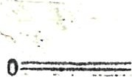
Hurt In Fall,

Edwin Wilhelm
Succumbs Here
Edwin John Wilhelm, 53, assist ant foreman of the boiler shop at the Canadian • National Railways shops here, died in the Stratford General Hospital Wednesday night. He had been taken to hospital after a fall on the cellar •steps of his home during the power failure Tuesday night.
Mr. Wilhelm had lived in Stratford almost all his life. He was born in Baden, on Feb. 5, 1897, a son of the late John Wilhelm and Minnie Heideman Wilhelm. The —CA mily when was a child. On Sept. 19, 1923, he married Emma Heinbuch. He was a member of Zion Evangelical Lutheran Church. Mr. Wilhelm was keenly interested in farming, and for many years had operated a farm just outside the city limits, as a hobby.
Surviving besides his wife are three daughters, Jean, Muriel and Bette, all at home; one son, Glenn, R.R. 3, Tavistock. There are foul brothers, Jacob, London; Theodore, R.R. 2, Tavistock; Walter, Flint, Mich., and Carl, R.R. 2, Tavistock: and three sisters, Mrs. Frank (Ida) King, 94 Mowat st.; Mrs. Fred (Minnie) Kudob, 73 Parkview dr., and Mrs. Moore (Rose) Kells. Mitchell.
The body is resting at the Heinbuck Funeral Home, 156 Albert st. until Saturday morning at '10:30 o'clock, when removal will be made to Zion E van ge l i c a I Lutheran Church for a service at 2:30 0'clock Rev. Karl J. Knauff will officiatv and burial will be in Avondale ceme8 tery.

EDWIN JOHN SAMUEL WILHELM STRATFORD, ONTARIO
17 . Edwin John Samuel Wilhelm, was born February 5, 1897 at Baden,
Ontario, and he died from an accidental fall on February 15, 1950. Married September 19, 1923 at Lot 36, Conc. 4, South
Easthope Township (Heinbueh Farm) to Emma Marie Elizabeth Heinbuch, born July ID, 1901. She died on March 29, 1978 following several strokes . They are buried in Avondale Cemetery, Stratford, Ontario . He served in the Canadian
Army during WWI, and worked all his life at the CNR shops in Stratford where he was a foreman in the boilermaker depart— ment . He later bought the Heinbuch farm but it was sold after his death. They lived all their life at 700 Downie Street, Stratford, Ontario. They had four children. Below are their wedding picture and several others see captions .
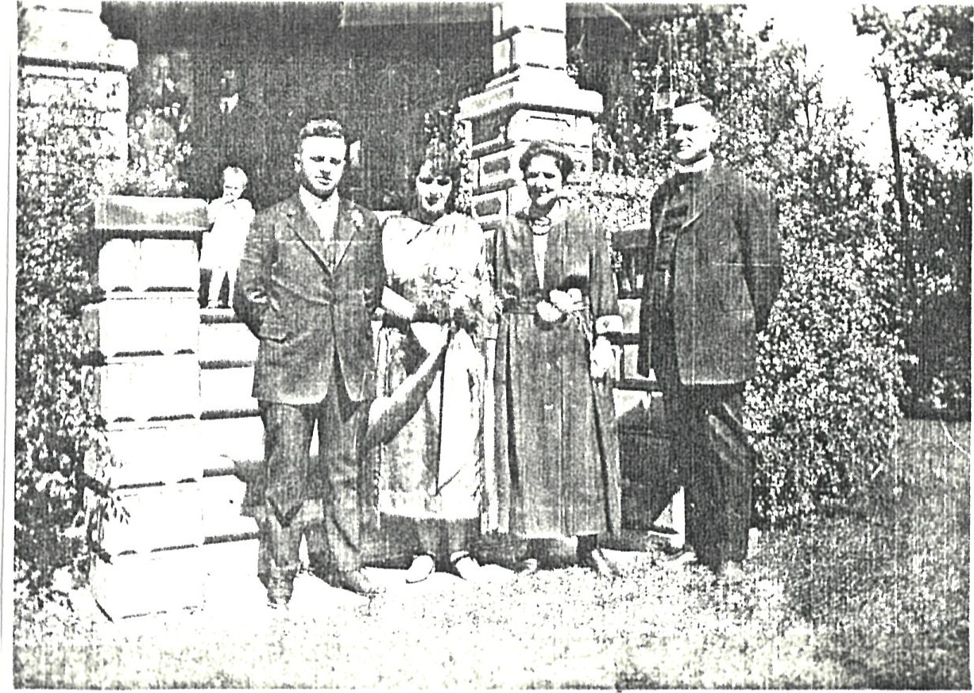
September 19, 1923, Ed, Emma, Mrs. & Rev. O. T. C. Stockmann at
Heinbuch Farm
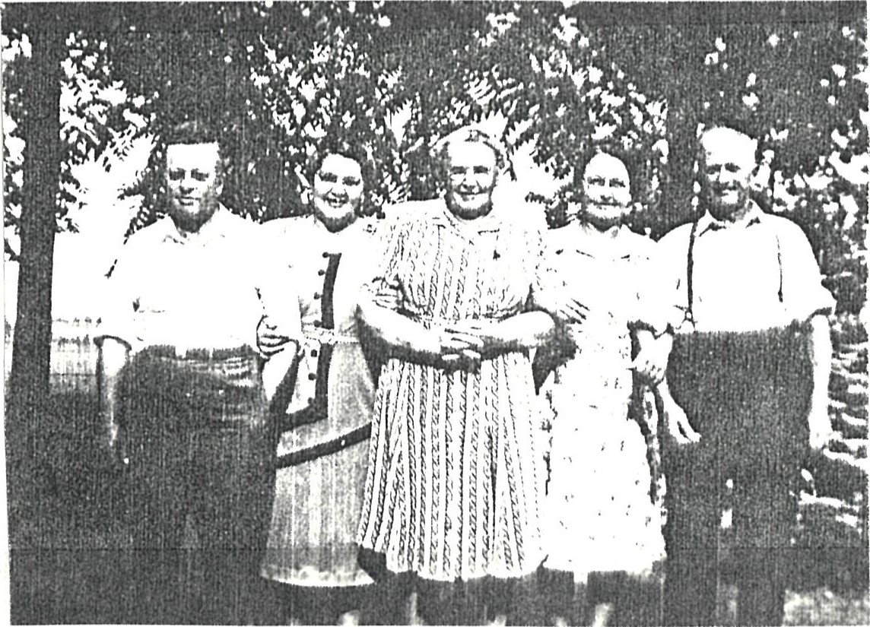
Photo taken at Ted's farm in the late 1940's
Ed, Emma, Mary Heinbuch (Emma' s mother) , Flora, and Ted
Jean Marie at home, May 18, 1925 . On June 26, 1954 she was married to Erlyn Wilker, born April 20, 1917. Erlyn was an Industrial Arts Teacher in Toronto and Stratford, and in his retirement he has built scale models of many train locomotives, and has also built small automo— biles. He operates a small museum at their home in Strat— ford. He is also an ardent camera buff, and has filmed documentaries that were shown on Canadian Television. They are both active in church work. No issue. They live at 212 Church Street, Stratford, Ontario, Canada N5A 2R6.
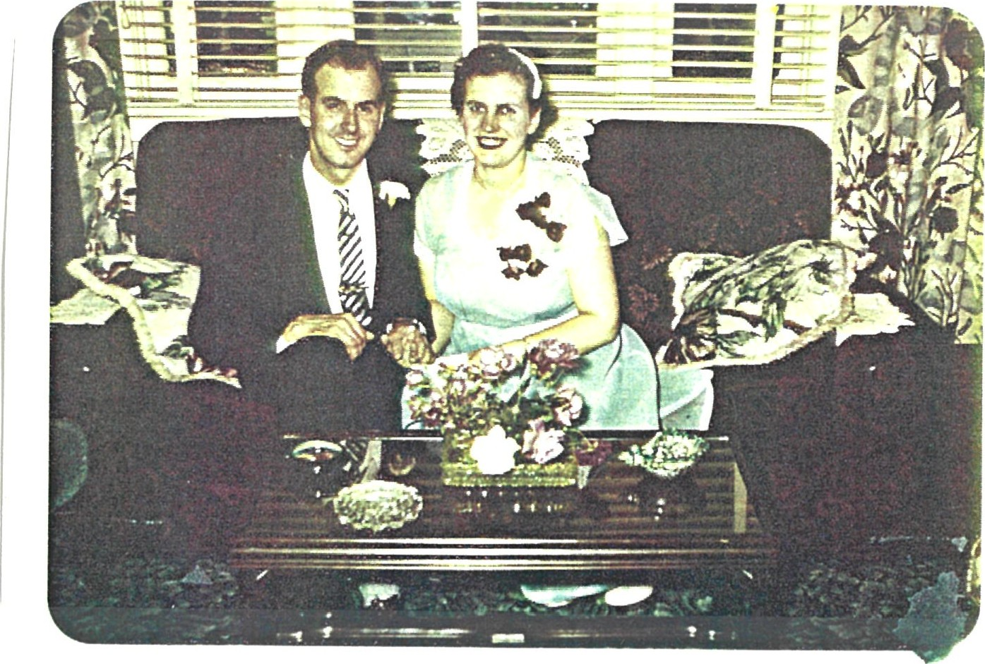
Jean & Erlyn, June 26,
Following their wedding
172 . Glenn Albert Wilhelm, born at home, March 2, 1928; he was married on July 2, 1956 to Johanna (Ann) Marshall, born July 6, 1933 At Inglis, Manitoba. He had lived and worked on the farm until Ed' s death, and since then he has worked at the Kroehler Manufacturing Co. and Ann works at Samsonite. Glenn is a respected baritone soloist in the Stratford area, sings at church, weddings, concerts, and other functions , and he is very active in church work at Zion Evangelical Lutheran Church. They live at 700 Downie Street, Stratford, Ontario N5A 1 Y 7. They had two children: Robin and Janice. Below is a photo of their wedding party.
Rear - Erlyn Wilker, Bette, Gordon Alles, Her ta Pethick,
(Ann's sister) , Noel Clark, Alma All es (Ann's sister)
Front — Glenn and Ann
Robin Glenn April 8, 1957 at Stratford General Hospital . On October 16, 1982 he married Beverley Ann Norton, who was born April 30, 1953 in York County ( Toronto) . Rob is a photographer for the Stratford Beacon Herald, is also a singer in the community and is active in church work; Bev works as a claims adjuster for Coop Insurance Co. They live at 273 Cambria Street, Stratford, Ontario, N5A IH9, and they have one daughter:
17211 . Julie Ann Wilhelm, born June 17, 1985, at Stratford General Hospital .
1722 . Janice Laura Wilhelm, born September 8, 1959 at Stratford
General Hospital. She is single, lives at home.
The picture below was taken at Rob and Bev's wedding
Glenn, Ann, Rob, Bev and Mr. & Mrs. Norton, October 16, 1982.
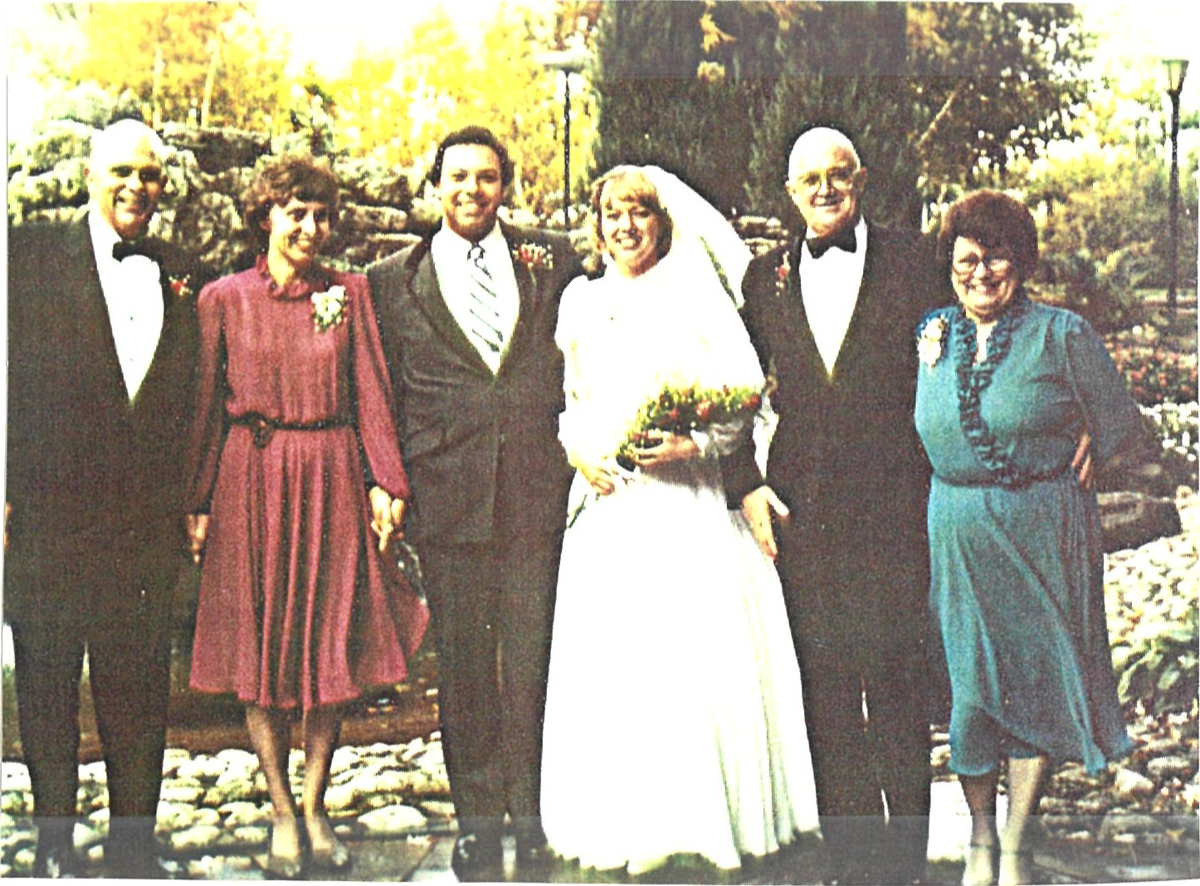

- . Robin Glenn Wilhelm, born April 8, 1957 at Stratford General Hospital . On October 16 , 1982 he married Beverley Ann Norton, who was born April 30 , 1953 in York County ( Toronto) . Rob is a photographer for the Stratford Beacon Herald , is also a singer in the community and is active in church work; Bev works as a claims adjuster for Coop Insurance Co. They live at 273 Cambria Street, Stratford, Ontario, N5A IH9 , Tel. (519) 273-3929, and they have two daughters :
- . Julie Ann Wilhelm, born June 17 , 1985, at Stratford General Hospital .
- . Amanda Emma Wilhelm, born May 31 , 1987 , at Stratford General Hospital .
- . Janice Laura Wi 1 helm, born September 8 , 1959 at Stratford General Hospital . She is single, lives at home .
The picture below was taken at Rob and Bev' s wedding
Glenn, Ann, Rob, Bev and Mr. & Mrs. Norton, October 16, 1982 .

.0
Muriel Ida September 30, 1929 at home . She was married in Calgary, Alberta, on September 3, 1954 to Roy Crouse, born August 28, 1933. They have been retired for several years; he previously worked in the accounting department at Calgary Power (where they met) , and she worked at various office jobs. They have traveled all over the world, and they now live at R.R. #1, Sorrento, BC Canada VOE 2W0. They have no children.
S i kS öAJ 6 ebÆD
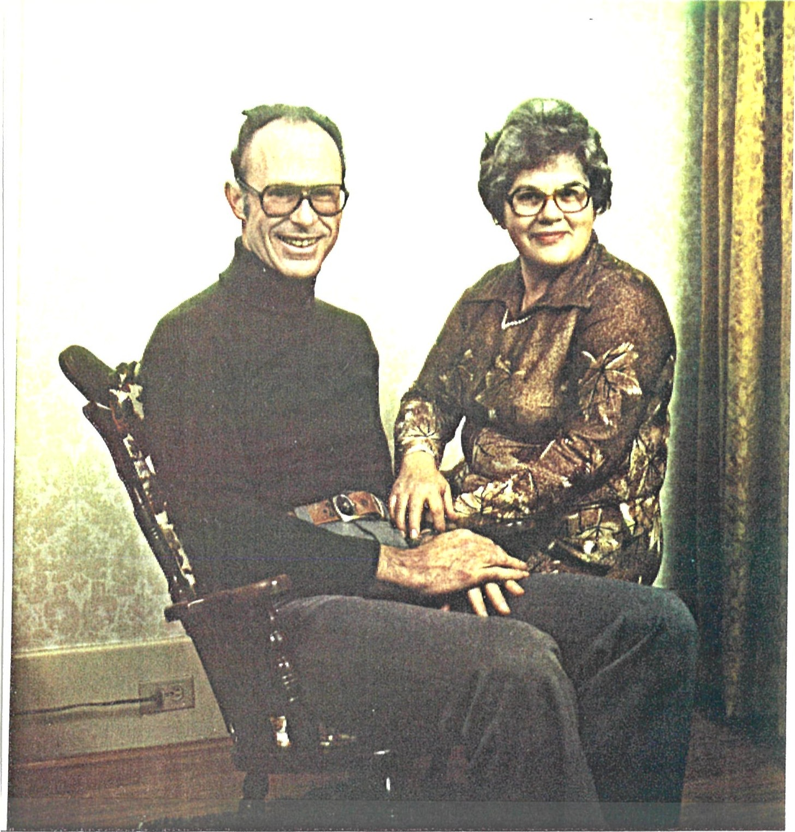
174 . Elizabeth (Bette) Anne Wilhelm, born January 10 , 1934 at Stratford General Hospital . She was married by Rev .
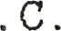Stockmann who married her parents , at Zion Evangelical Lutheran Church, Stratford, on May 28, 1955 to Noel M. Clark, born December 3 , 1930 in Calcutta, India where his parents were missionaries . Noel is a B. Sc. graduate of the University of Western Ontario and obtained his M. Sc. from Northeastern University in Boston. In 1957 they moved to the US where Noel works as an electronics engineer. Bette underwent major open heart surgery to repair a congenital malfunctioning valve on November 7 , 1978 and had a very successful recovery . She now works as an Administrat ive Assi stant/Secretary . They are moving mid—November 88 to 2957 Santa Inez Drive (Mission Hot Springs ) in Minden, Nevada, 89423. . . in semi-retirement. Below is a photo following their wedding in 1955, and a family picture taken December 26, 1981 is on page 61 there are now 2 more grandchildren, Jon and Ashley .

174 . Elizabeth (Bette) Anne January ID, 1934 at
Stratford General Hospital . She was married by Rev. O. T. C. Stockmann who married her parents, at Zion Evangelical Lutheran Church, Stratford, on May 28, 1955 to Noel M .
Clark, born December 3, 1930 in Calcutta, India where his parents were missionaries . Noel is a B. Sc. graduate of the University of Western Ontario and obtained his M. Sc. from Northeastern University in Boston. In 1957 they moved to the US where Noel works as an electronics engineer. Bette underwent major open heart surgery to repair a malfunction— ing valve on November 7 , 1978 and had a very successful recovery. She now works as an Administrative Assistant/ Sec— retary. They live at 1510 N . Darcy Ave. Simi Valley, CA 93065, and they plan to retire soon to the Minden area of northwest Nevada (near Lake Tahoe) . They have five children . Below is a photo following their wedding in 1955, and a family picture taken December 26, 1981 is on page 57 . . . there are now 2 more grandchildren, Jon and Ashley.
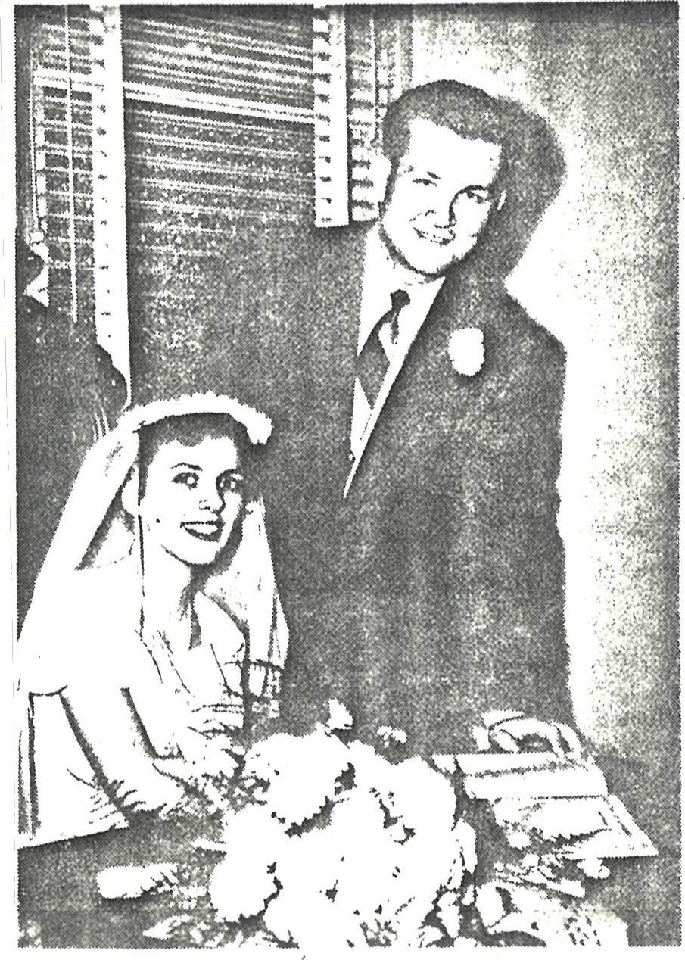
1741 . Nancy Lynn Clark, born April 17 , 1957 at Malden Hospital, in Malden, Massachusetts . She was married on March 26, 1977 to Arthur J . Dicken Jr. , ( Butch) , born May 24 , 1956 . They have three children, and they currently live at 17430 Kramer ia Ave. , Rivers ide , CA 92504 where he works as a Paramedic and attends school — he is mid-way to becoming a Registered Nurse.
- . Matthew James Dicken, born December 4, 1979 , at Hoag Memorial Hospital in Huntington Beach, CA .
- . Jon Christopher Dicken, born December 19 , 1982 , at Riverside General Hospital, Riverside, CA.
17413. Ashley Noelle Dicken, born June 15 , 1985, at Washoe County Medical Center, Reno, Nevada .
- . Geoffrey Noel Clark was born on September 16 , 1959 at Malden Hospital, Malden, MA. He received his B . Sc. in Animal Science from the University of California, Davis in 1981, and his Doctor of Veterinary Medicine degree at UC Davis on June 14, 1986. He worked the first year as an Interne at the Animal Medical Center in New York City , and has just completed the first of a 3—year residency in surgery at the Tufts University Veterinary School of Medicine in No. Grafton, Mass . Following this he plans to return to the west coast to practice there . His current address is 5 Bedford Drive, No. Grafton, MA 01536.
- . Carol Anne Clark, born January 19 , 1962 at Malden
Hospital , Malden , Mass . She graduated from the University of California at Davis, CA on June 21, 1986, and was awarded a full fellowship to do her doctoral work for four years at Yale University, New Haven , Connecticut , studying Anthropology. She is currently living at 1214 Chapel Street, #33, New Haven, CT 06511.
174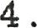Victoria Elizabeth Clark was born December 6, 1964 at Grossmont Hospital, La Mesa, CA. (San Diego) . Vicki also underwent successful open heart surgery in 1982 to close a congenital hole in her heart. She graduated with her R.N. and Associate Degree in Nursing on June 5, 1987 . On August 22, 1987 she married Stephen Jerome Jean, born June 3 , 1956 in Sault Ste. Marie, Michigan; they lived for eight months in Houston, TX but returned to CA in April 88 . They are living at 1330 Acapulco Drive, Simi Valley, CA 93065 . Vicki works in Labor & Delivery at Adventist Hospital , Simi , and Steve is in sales for Stairmaster, who make gym equipment for health clubs .
1745 . Felicia Christine Clark, born September 22 , 1966 at Malden Hospital, Malden, MA. She graduated from UC Davis , California, majoring in English. She studied at Paul Valery University in Montpellier, France for the 1986—87 school year with the University of California Study Abroad program, and took all her classes in French. She graduated in June 1988, is now working part-time and trying to complete her Masters . She lives at home .
Family Group December 26, 1981.
Rear — Vicki holding Candy, Geoff with Zeke , and Felicia with Chauncey (Lhasa Apso dogs )
Sitting — Carol, Bette, Noel
Butch, Nancy holding Matthew ,

- . Victoria Elizabeth Clark was born December 6, 1964 at Grossmont Hospital, La Mesa, CA. (San Diego) . Vicki also underwent successful open heart surgery to close a congenital hole in her heart . She is now a nursing stu— dent, and she will graduate in June 1987 . She lives at home .
- . Felicia Christine Clark, born September 22, 1966 at
Malden Hospital, Malden, MA. She is a student at UC Davis, California, majoring in English. She will be studying at
Paul Valery University in Montpellier, France for the 1986— 87 school year with the University of California Study Abroad program, taking all her classes in French. She lives at home when not at school .

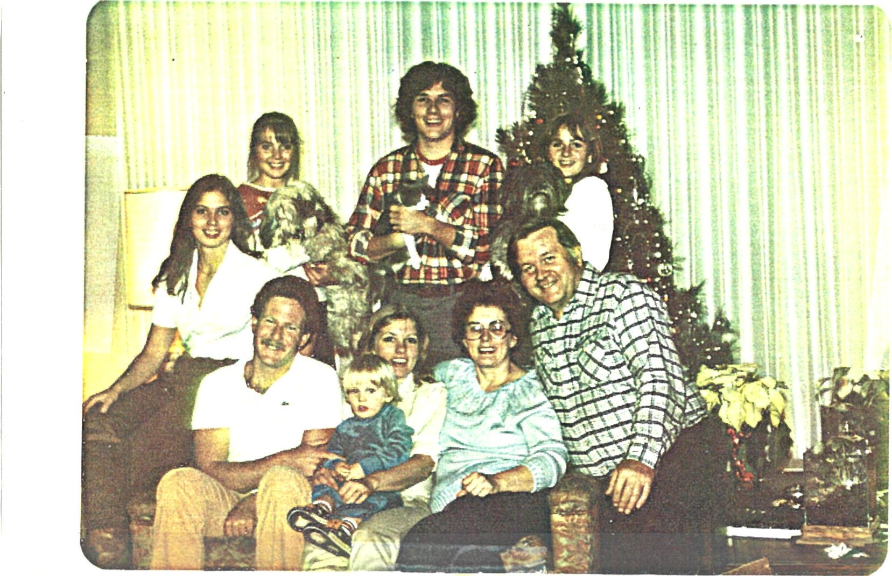
Family Group — December 26, 1981.
Rear — Vicki holding Candy, Geoff with Zeke, and Felicia with Chauncey (Lhasa Apso dogs)
Sitting — Carol, Bette, Noel
Butch, Nancy holding Matthew ,
ALBERT OSCAR KARL WILHELM STRATFORD, ONTARIO
18 . Albert Oscar Karl Wilhelm, born August 24, 1B99 in
Petersburg, Ontario, and he died from a heart at tack on
January 17, 1945. He was married on September 19, 1921 at
Trinity Lutheran Church, Sebastopol to Edna Anna Eva Schaefer, daughter of Emmeline (Witzel) and John Schaefer, born October 6, 1898 at home in East Zorra Township, Oxford County . She died on March 12, 1985, at Hensall, Ontario. He worked for the CNR Shops in Stratford, and lived all their married life at 690 Downie Street, in Stratford. They had four sons:
[Edna remarried after Bert' s death, to Lyle Everett Youn, in December 1952. He died February 22, 196.3 ]
Below are some photos taken at their wedding and one of Bert and Edna some years Later on the lawn at Ed' s house.
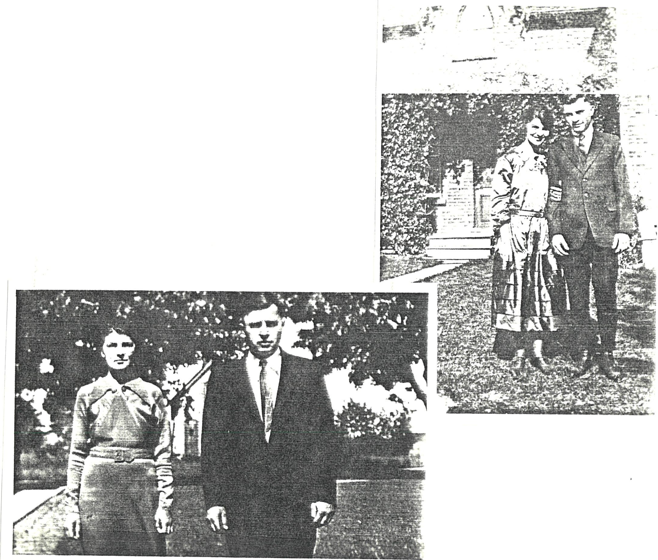
September 19, 1921 at Bert and Edna Schaefer's Wedding
Saluting the Happy Couple
Ed Wilhelm, Bert Wilhelm, Rev. O. T. C. Stockmann, Jack
Schaefer (Edna' s dad) , John Wilhelm (Grandpa) and possibly Jacob Wilhelm (John' s brother— resembles picture on p. 3 )
These are snaps of Bert' s four boys, Ron taken in 1970 , and Doug, Gord and Walt taken in the late 50's or early 60's

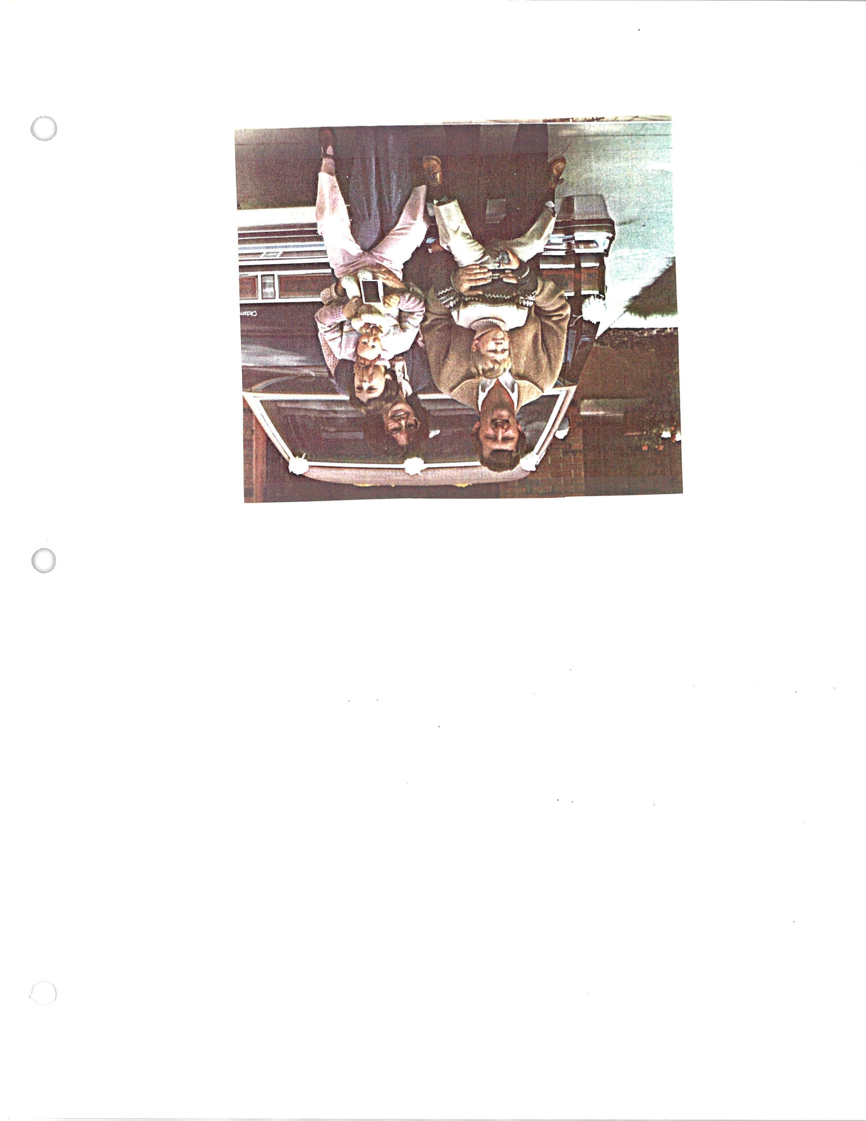

1 81 . Gordon John Wilhelm was born November 1 , 1924 in Stratford,
C)ntario . On March 27, 1948 he married Mildred Jean (Millie) McTavish, born November 28, 1927 . He served in the Canadian Army during WWII, and he is now employed by Muellers of
Sarnia and Millie works as a secretary at Carruthers Medical Clinic. They have purchased 35 acres (mostly wooded) and they have built a home where they now reside, R.R.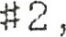
Wyoming, Ontario, NON ITO . They have one daughter:
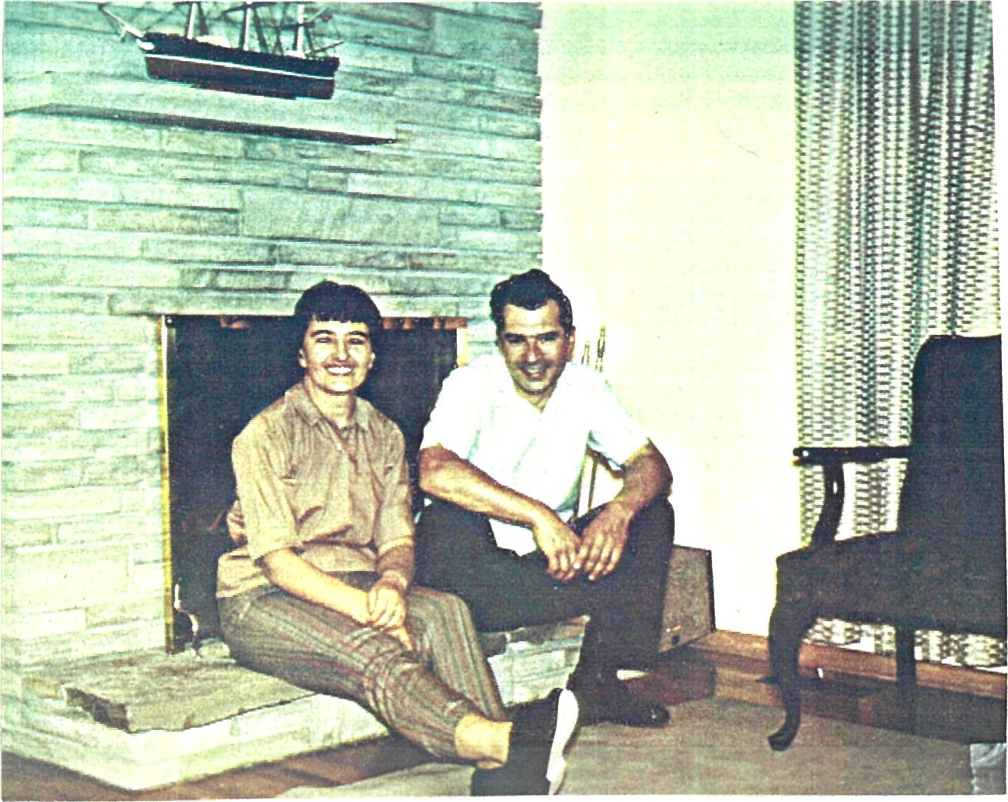
Gordon and Millie at their home in Wyoming, Fairly Recent Photo | Ontario
1 811 . Valerie Fern Wilhelm, born October 25, 1949 in Kitchener, Ontario . She was married July 1, 1972 at Sarnia, Ontario, to John Shrumm, born May 11, 1949. Both Valerie and John are school teachers . They reside at 1681 Trinity Crescent, Sarnia, Ontario N 7 S 5P8. They have two children :
181 1 1 . Jennifer Leigh Shrumrn, born April 2, 1976 at Sarnia, Ontario .
18112 . Matthew Gordon Shrumm, born June 19, 1978 at Sarnia,
Ontario .
1 82 . Walter Albert Wilhelm, was born July 21 , 1926 . He was married on June 4, 1955 at Sebastopol, Ontario, to Florence Alice Player, born January 20, 1934. They live in Stratford where Walter is employed by the Beacon Herald newspaper. Walter underwent quadruple by—pass surgery in March 1986 and while recovering he got pneumonia; he had been very sick, but last reports were that he was recovering nicely . They live at 168 Strachan Street, Stratford, Ontario, N5A 2B.3 , and they have two daughters
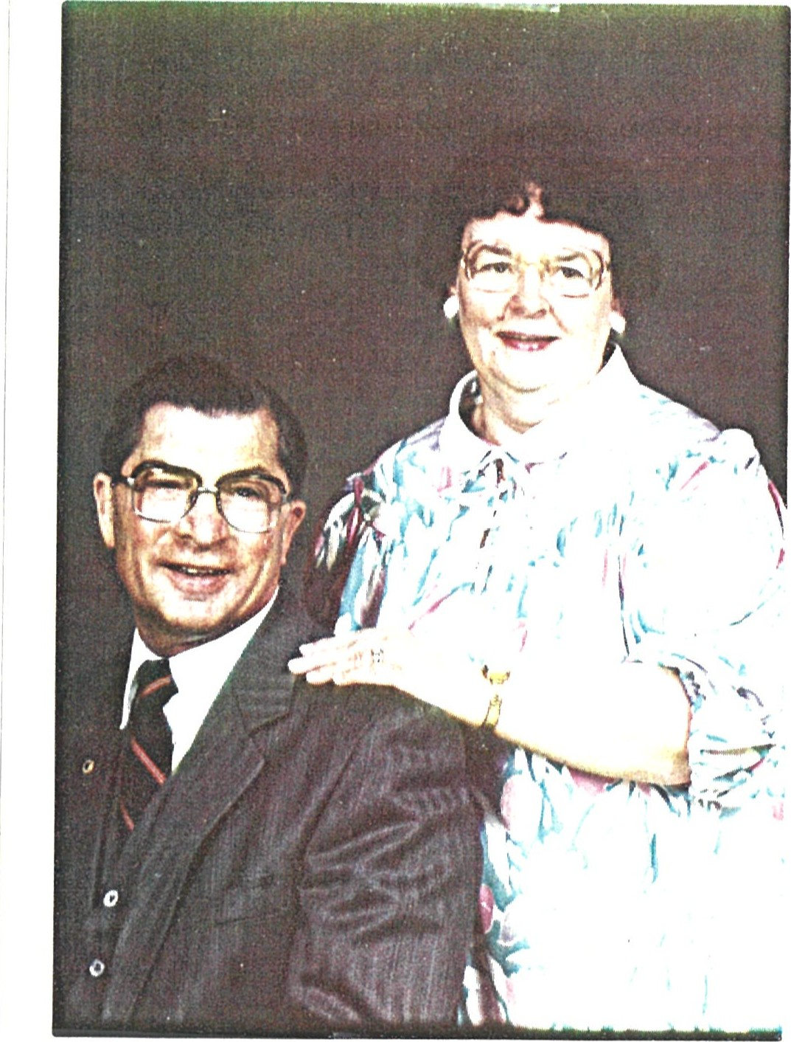
Walter and Florence 1985

65
1821 . Catharine Elizabeth September 21, 1956 at
Stratford, Ontario. On May 27, 1978 she married Steven George Davidson, born May 3, 1955, at Stratford. Steve works at International Artcraft, and Cathy works in accounting. They live at 91 Maple Avenue , Stratford , Ontario, N5A 7G8. They have three daughters :
18211 . Rebecca Lynne Davidson, born December 3 , 1982 at Stratford, Ontario .
- Pamela Catharine Davidson, born March 19 , 1985, at Stratford.
- Kimberly Anne Davidson, born August 6 , 1988 , at Stratford.
Below is a school picture of Cathy taken in October , 1972.
1822 . Vicki Lynn Wilhelm, born February 11 , 1959 at
Stratford, Ontario. On November 6 , 1981 she married John Leslie Player, born June 25, 1957 at Stratford, Ontario . Vicki and John operate a farm at R.R. #2, Gadshill, Ontario NOK IJO . They have three children :
18221 . Lisa Dawn Player, born September 13, 1984 at Stratford, Ontario .
- Mark Adam Player, born January 31, 1986 at Stratford, Ontario .
- Gregory John Player, born August 19, 1988 at Stratford, Ontario .
Below is a school picture of Vicki taken in October, 1972.

66

1821 . Catharine Elizabeth September 21 , 1956 at
Stratford, Ontario. On May 27, 1978 she married Steven George Davidson, born May 3, 1955, at, Stratford. Steve works at International Artcraft, and Cathy works in account— ing. They live at 91 Maple Avenue, Stratford, Ontario, N5A 7G8. They have two daughters :
18211 . Rebecca Lynne Davidson, born December 3, 1982 at Stratford , Ontario .
18212. Pamela Catharine Davidson, born March 19, 1985, at Stratford. Below is a school picture of Catharine taken in October 1972
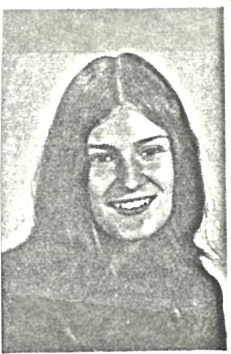
1822 . Vicki Lynn Wilhelm, born February 11 , 1959 at Stratford,
Ontario. On November 6 , 1981 she married John Leslie
Player, born June 25, 1957 at Stratford, Ontario. Vicki and John operate a farm at R.R. #2, Gadshill, Ontario NOK IJO. They have two children :
18221 . Lisa Dawn Player, born September 13, 1984 at Stratford, Ontario .
18222. Mark Adam Player, born January 31 , 1986 at Stratford,
Ontario .
Below is a school picture of Vicki taken in October 1972
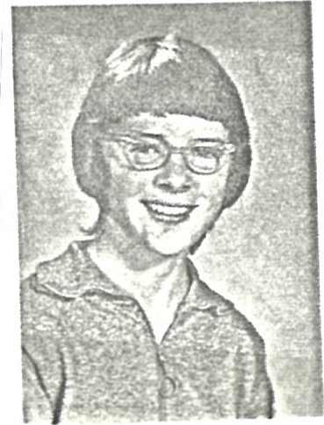

66
1 83 . Ronald Edwin May 26, 1928 at Stratford,
Ontario . On June 4, 1955 he married June Phyllis Hamilton, born June 21 , 1934, at Saskatoon, Saskat— chewan. Ron died on August 28, 1972 . Ron was employed all his life by Mutual Life of Canada. They had four children. June remarried in 1986 to Orville I ven Moger (Moe) .
St Albert Evangelical Lutheran
11 Glenview Crescent St Albert, Alberta
Pastor:R.O.01son Organist :Mrs D. Thanson Soloist *Mrs Beatrice Loshack
e'
Service held at Andrews McLaughlin Chapel, Edmonton
RONALD EDWIN WILHELM
Ronald was born at Stratford, Ontario on May 26, 1923. It. was here that he recieved his early training in the School, as well as in the Church. He was baptized and confimed in the Zion Evangelical Lutheran Church ab Stratford.
On June 4, 1955, he was married to June Phyllis Hamilton in Saskatoon.God blessed this union with four children, two sons :Howard born in Saskatoon, and David born in Toronto ; and two daughtezw,Jan and Carolyn both born-•--—-"' in Edmonton.
Since beginning work Ron has been with the Mutual Life of Canada, and as such they have lived in various parts of Canada, having resided in St Albert for the past ten years .He was to recieve his 25th Anniversary Award in October of this year.
Ron and his family are Charter Members of St Albert Evangelical Lutheran, actively starting out by worghip• ping in the School House, and then in our new Church since October 7,1966øHe lived for his family, his Church, and young people . Of special mention is the part that Ron played in his Church, having served in various capacities ; Chaiman of Council;Sunday School Superin•• tendent 'keeping the Church look like it does on the outside, lam etc.
Ron passed away at his home on Monday, August 29, 1972, He leaves to mourn his loss :his loving wife, June ;his children—Howard, IhridyJan,and Carolyn; his mother, Mrä Edna Youn, and two brothers (Walter and Douglas )living in Stratford, Ontarion;and brother Gordon of Sarnia, Ontario;and a host of relatives and friends .
Today we sorrow, but I know that all of us thank God for having Imovm and shared with Ron. To la-row him was to love him:
God bless, and keep you June, each of you children, and loved ones, through this day and in the years to come! Pallbearers : F.A.Robinson;Arthur Southworth; Con Richens Don Chamney;Ross Grant ;and bill Findlay, all of BLtua1. Fellowshi and Lunch following the intement at the
Comxng!
Albrecht Dürer (1471-1528) Germany's greatest No. 2994 artist. Original in Albertina Museum, Vienna.

67
Ron and June' s Family
Howard James Lori, Jared & David Ronald
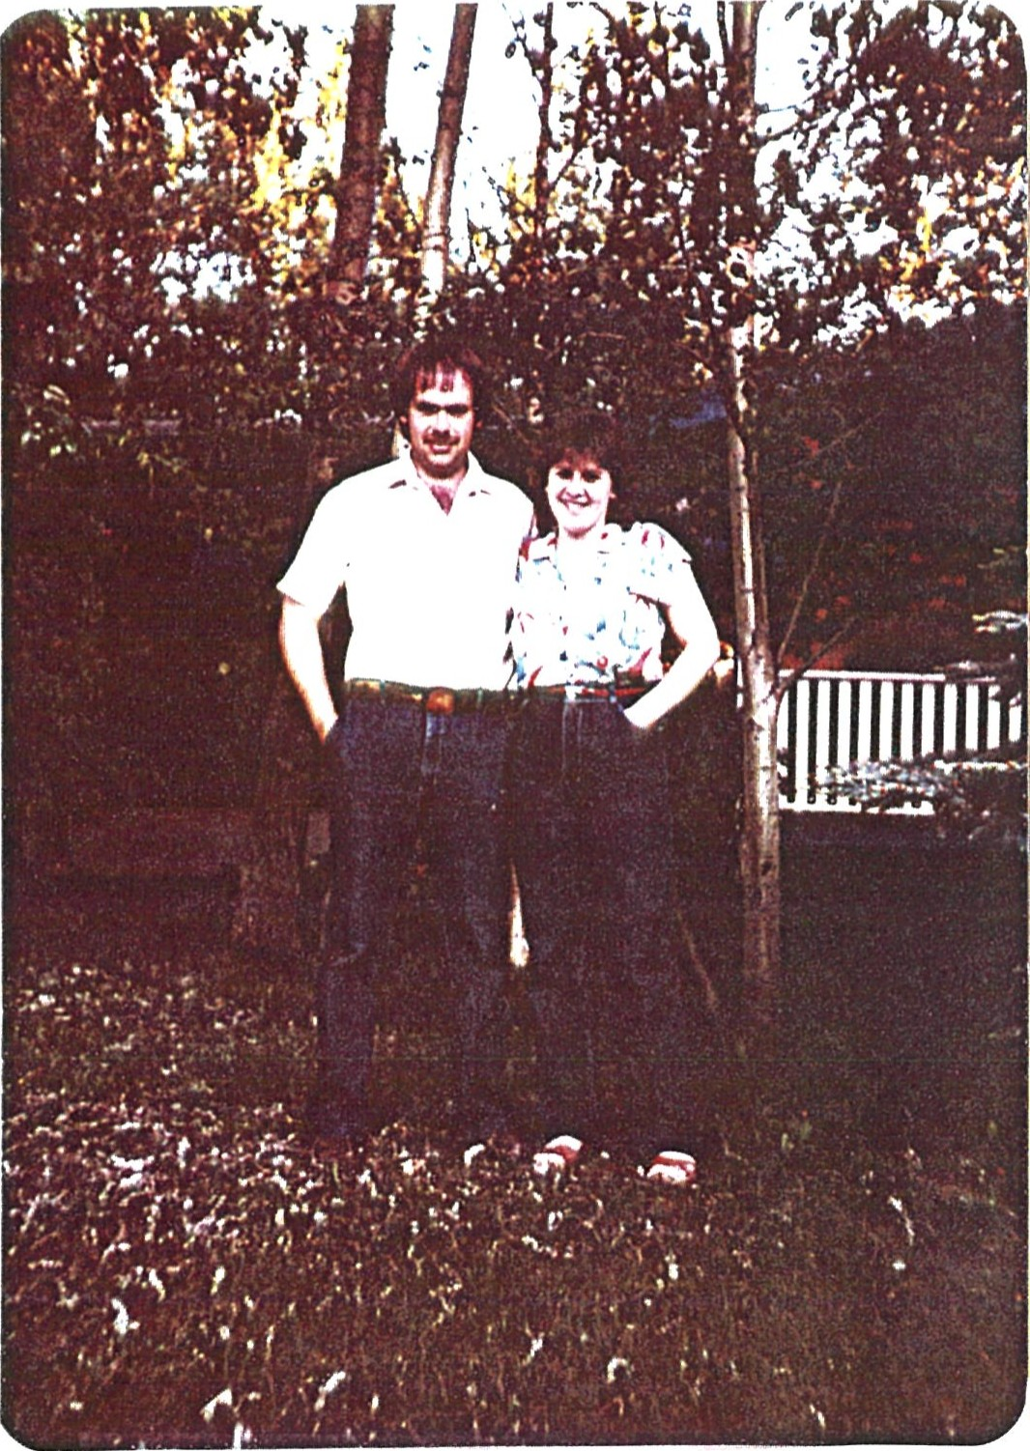
Gordon Taves Jan Carolyn Ann
67a

1831 . Howard James Wilhelm, born December 4, 1955 at Saska— toon, Sask. On August 28, 1982 he married Debbie Lee Christensen, born December 4, 1956 at Provost, Alberta. He works as Sales Manager for Sands Seed Farm Ltd. , and they now live at 2708 46 Ave. , Lloydminster, Saskat— chewan , S9V IWI. They have one daughter :
18311 . Jessica June Wilhelm, born December 6 , 1983 Albert , Alberta.
1832. David Ronald Wilhelm, born November 18 , 1957 at Toronto , Ontario . On May 30, 1980 at St. Albert, Alberta he married Lori Jean Munro, born November 5, 1959 in Edmonton. David works for CNR, and Lori works part-time for Safeway . Their new address is 10722-98 Avenue, General Delivery, Morrinville, Alberta, Canada TOG 2C0.
They have three children.
18321 . Jared David Wilhelm, born July 3, 1982 at St. Albert .
- Joshua Daniel Wilhelm, born September 4, 1984 at St. Albert , Albe rta.
- Meghan Paige Wilhelm, born October 1 , 1987 St. Albert , Al berta.

68
1833 . Jan Lisa Wilhelm, born January 13, 1961 at Edmonton, Alberta . On July 21, 1984 she married Gordon Neil Taves, born July 16, 1958 ( she kept her own name) in Edmonton , Alberta. She is a teacher of special education kids, and he is an electrician. They have just finished building a new home (their own labor! ) and they have one son . They now 1 ive at 282 Heath Road, Edmonton, Alberta, Canada T6R IE9.
18331 . Jonathan David Taves , born November 6, 1987 in Edmonton , Alberta, weight 9 1b. 6 oz.
1834 . Carolyn Ann Wilhelm, born November 8, 1962 at Edmonton, Alberta. She is an excellent swimmer, and when a young girl she used to compete in Swim Meets all over the west. On June 19, 1986 near Spruce Grove, Alberta she married David Michael Pittman, born September 1 , 1952 . Carolyn manages a leather goods store and David works as special events coordinator for a small town outside Edmonton . They live at R.R. Box 8, Site 5, Spruce Grove, Alberta TOE 2C0.

68 a
WILHELM — In memory of the late Douglas (Hub) Wilhelm, who passed away two years ago, suddenly at his home, December 18, 1985.
We all have memories to keep.
Phyllis
WILHELM — In loving memory of a dear Dad, Douglas (Hub) Wilhelm who passed away two years ago December 18, 1985. I Sit and remember
How we laughed and how we smiled
I remember all the good times we shared From the time I was a child,
I remember those early Sunday mornings
When the course we would walk We'd joke a little, laugh a bit
And have long meaningful talks
Saturday afternoons
I would drive you to the club
We'd open the door
And I'd watch everybody smile and say
"Here comes Hub"
It's been two years now
Since you had to go
And it is still very hard Not to let my feelings show
People always tell me
You've gone to a better place
And not to be sad
But it isn't easy to lose
The best friend you ever had
Is there something else after this life?
No one knows for sure
All I can do is hope there is
So we can meet and laugh once more.
Love Bear
Merry Christmas, I miss you!
WILHELM In loving memory of my Dad, Douglas (Hub) Wilhelm who passed away suddenly two years ago December 18, 1985.
Two sad and lonely years have passed
Since the great sorrow fell
The shock that I received that day
No one can ever tell
The end came sad and suddenly No time to say goodbye
You were gone before I knew it And only God knows why
What I would give if I could say
' 'Hello Dad" in the same old way
To hear your voice, to see you smile To sit and chat with you awhile
I've never asked for miracles
But today iust_one would do
To see the front door open
And have my Dad walk through
Missed and loved always.
Merry Christmas, Dad.
Chris
WILHLEM — In loving memory of my dad, Douglas (Hub) Wilhelm, who passed away suddenly two years ago.
Dear Dad:
This year I couldn't look after your flowers. I was having a hard time dealing with you being gone. I couldn't go there and face it. It hurt too much. We shared our lives for 33 years and it's going to take a lot longer than two years to get used to never hearing, seeing, or touching you again. I miss you so much and you are always in my thoughts. Merry Christmas. Love is for Always,
Karen and Earl xxx

184 . Douglas Herbert Wilhelm, born September 28 , 1930 at
Stratford, Ontario. On June 3 , 1950 he married Phyllis E . Bailey , born February 27 , 1931 , at Stratford , Ontario . Doug worked for Kroehler Mfg . co. in Stratford. Doug died suddenly from a heart attack on December 18 , 1985, at home. He & Phyllis had three children were later divorced.
- . Karen Ann Wilhelm , born July 7 , 1952 at Stratford , Ontario . She was married on May 18, 1974 to Earl Harvey Filsinger , born July 10, 1951, at Stratford . They presently have no children; they operate Filsinger Music Store in Stratford, and reside at 56 West Gore Street, Stratford, Ontario, N5A IJ8.
Below is a picture of Doug and Karen at her wedding in 1974.
Doug and Karen, May 18, 1974
- . Douglas Steven Wilhelm ( called Steve) , born January 7 , 1961 at Stratford , Ontario . He was married in September 1983 to Lori Chornaby but the marriage lasted less than a year . Steve works in Real Estate , in London . Steve remarried on August 27, 1968 to Shelley Margaret Wilkinson at Zion Evangelical Lutheran Church in Stratford.
- . Chri stopher William Wilhelm, born June 13, 1965 , at Stratford, Ontario . He now Lives in London his mother .

69
184 . Douglas Herbert Wilhelm, born September 28, 1930 at St rat— ford, Ontario. On June 3, 1950 he married Phylli.s E.
Bailey, born February 27 , 1931, at Stratford, Ontario. Doug worked for Kroehler Mfg. Co. in Stratford, Doug died from a heart attack on December 18, 1985, at home . They had three children were later divorced.
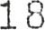41 . Karen Ann Wilhelm, born July 7 , 1952 at Stratford, Ontario.
She was married on May 1 d, 1974 to Earl Harvey Filsinger, born July 10, 1951, at Stratford. They presently have no children; they operate Filsinger Music Store in Stratford, and reside at 56 West Gore Street, Stratford, Ontario, N5A 1 J 8.
Below is a picture of Doug and Karen at her wedding in 1974.
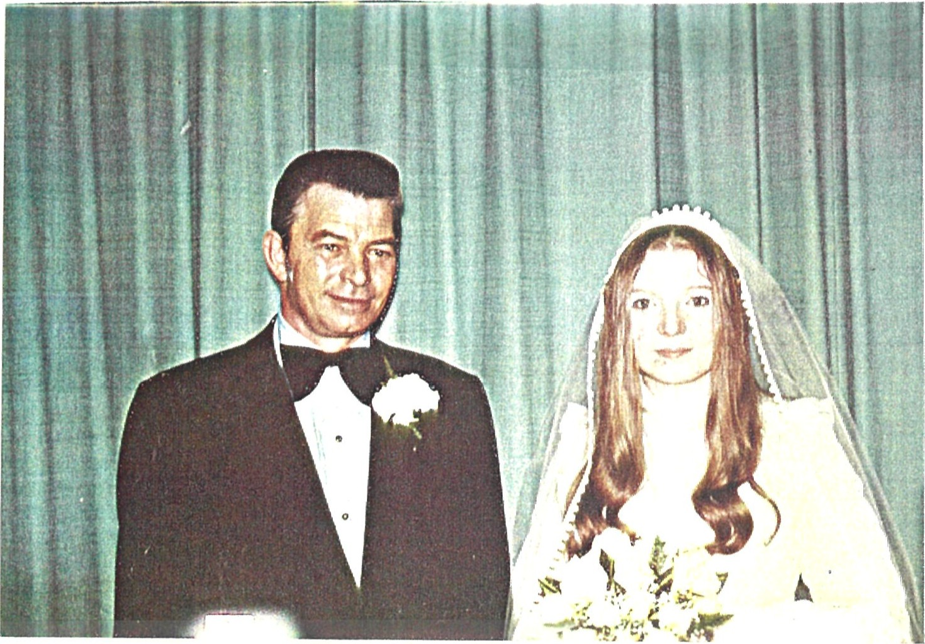
Doug and Karen, May 18, 1974
1842 . Douglas Steven Wilhelm (called Steve) , born January 7 ,
1961 at Stratford, Ontario. He was married in
September 1983 to Lori Chornaby but the marriage lasted less than a year. Steve works in Real Estate, in London. No address.
1 84.3 . Christopher William Wilhelm, born June 13, 1965, at Stratford, Ontario. He now lives in London with his mother.

69
ROSE LOUISE (WILHELM) KELLS - MITCHELL, ONTARIO
19 . Rose Louise Catharine (Wilhelm) Kells, born July 17 , 1901 at 74 Blake Street, Stratford, Ontario. She was married on October 16, 1926 at Zion Lutheran Church Parsonage to Moore Kells, born March 25, 1898; he died on December 16, 1974 and is buried in Presbyterian Cemetery, Main Street East , in Mitchell , Ontario , adjoining his former property . Until the summer of 1987 she lived in Mitchell, at the Coulton Apartments,
Coulton Drive ; she is now at Hillside Nursing Home, R.R. #5 Stratford, Ontario, N5A 6S6. They had six children: Keith, Joyce, Earl, Robert, Glenn and David.
Below is a copy of a portrait taken for her 75th birthday in 1976 - also a snapshot taken at Ed' s farm in the late 40's showing Rose, Jean, and Ida, with Glenn, Robert and David ( peeking behind Robert) in front .

70
ROSE LOUISE (WILHELM) æLLS - MITCHELL, ONTARIO
19 . Rose Louise Catharine (Wilhelm) Kells, born July 17, 1901 at
74 Blake Street, Stratford, Ontario. She was married on
October 16, 1926 at Zion Lutheran Church Parsonage to Moore Kells, born March 25, 1898; he died on December 16, 1974 and is buried in Presbyterian Cemetery, Main Street East, in Mitchell, Ontario, adjoining his former property. Rose still resides in Mitchell, at the Coulton Apartments, Coul— ton Drive; her address is Box 223, Mitchell, Ontario, NOK INC. They had six children: Keith, Joyce, Earl, Robert, Glenn and David.
Below is a copy of a portrait taken for her 75th birthday in 1976 also a snapshot taken at Ed' s farm in the late 40's showing Rose, Jean, and Ida, with Glenn, Robert and David (peeking behind Robert) in front .

70

191 . Keith Gordon April 14, 1927 in Stratford,
Ontario . Married ( 1 ) to Madeline Wolfe, born October 6 , 1935 . They had two sons, and divorced. He was married (#2) on April 19, 1975 to Kathleen Lorentz Riepert at the home of his mother , Coulton Drive , Mitchell, Ontario. Kathleen died on April 5, 1988, but he still lives at 24 Canterbury Avenue , Stratford , Ontario . Sons from 1st marriage:
1911 . Kenneth Michael Kells, born May 5, 1955. Married May 6, 1977 in Fullarton, Ontario to Sandra Laurine Marshall, born January 19, 1956 . They live in Bornholm, Ontario . They have one son-
19111 . Tyler Marshall Kells, born October 26 , 1982 at St . Joseph's Hospital, London, Ontario .
1912 . John Richard Kells, born February 20 , 1959 . Married June 16 , 1979 in London , Ontario , to Dulcie -Anne Claxton, born May 4, 1958. Now divorced. They have one son—
19121 . Jason Richard Kells, born July 2, 1980.
192 . Joyce Minnie Kells , born June 2 , 1929 in Stratford, married September 5, 1955 in Grace Lutheran Church, Mitchell , to George McEwan McKenzie, born August 18 , 1924 at his home on Meadowbank Street , Dumbarton, Scotland . No children. They live at 2000 S. Eads , Apt . 503, Arlington, VA. USA 22202, where Joyce was employed by COMSAT, (now retired) and George was a carpenter (retired in August 1986) . Their wedding picture is below.
George & Joyce McKenzie September 5, 1955

71
19 1 . Keith Gordon April 14, 1927 in Stratford,
Ontario. Married ( 1 ) to Madeline Wolfe, born October 6 ,
1935 . They had two sons, and divorced. He married ( #2 ) on April 19, 1975 to Kathleen Lorentz Riepert at the home of his mother, Coulton Drive, Mitchell, Ontario. They live at 24 Canterbury Avenue, Stratford, Ontario . Sons from 1st marriage :
19 1 1 . Kenneth Michael Kells, born May 5, 1955. Married May 6, 1977 in Fullarton, Ontario to Sandra Laurine Marshall, born January 19, 1956. They live in Bornholm, Ontario. They have one son—
- 1 . Tyler Marshall Kells, born October 26, 1982 at St. Joseph' s Hospital, London, Ontario.
- . John Richard Kens, born February 20, 1959. Married June 16, 1979 in London, Ontario, to Dulcie—Anne Claxton, born May 4, 1958. Now divorced. They have one son—
19121 . Jason Richard Kells, born July 2, 1980.
- . Joyce Minnie Kells, born June 2 , 1929 in Stratford, married
September 5, 1955 in Grace Lutheran Church, Mitchell, to
George McEwan McKenzie, born August 18, 1924 at his home on Meadowbank Street, Dumbarton, Scotland . No children . They live in Arlington, VA. , USA, where Joyce was employed by COMSAT, (now retired) and George was a carpenter ( retired in August 1986) . Their wedding picture is below.
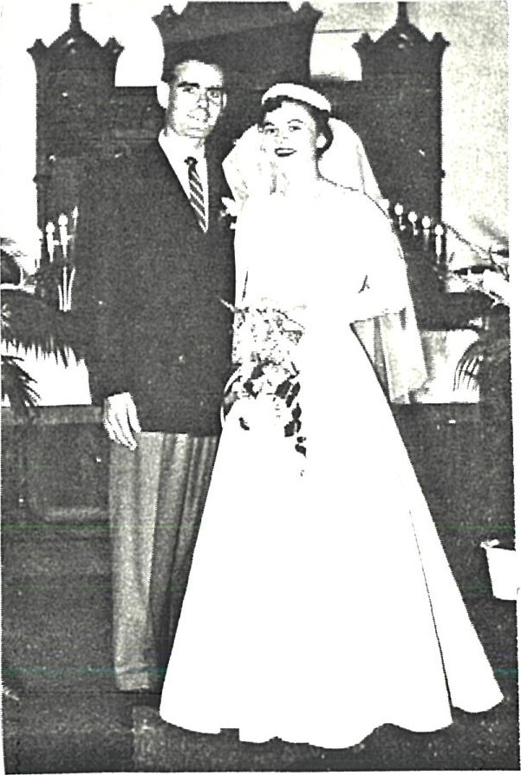
George & Joyce McKenzie
September 5, 1955
- . Earl Clark July 9, 1931 at home in Mitchell, Ontario . Married August 14, 1954 in Medicine Hat, Alberta, to Nessie ELI a Sparrow, born July 12, 1931 in Creston, BC. They had three children, and currently live in Phoenix, AZ ,
USA. Earl has worked in the US mainly for Eastern Airlines.
1931 . Rodger Earl Kells, born October 13, 1955 in Alexandria, VA. He is an engineer for Microrel, and lives at 957 West 10th Street, Mesa, Arizona 85201 .
19.32 . Donna Susan Kells, born March 24, 1958 in Alexandria, VA. Lives with her brother at 957 West 10th Street, Mesa, AZ 85201 ( 602 ) 962-5587 . She is a teacher.
19.33 . Ronald Clarke Kells, born April 16, 1962 in Alexandria, VA. He is an engineer with General Dynamics, in Yuma, Arizona.
194 . Robert William Moore Kells, born April 13, 19.38 in Stratford, Ontario. Married September 3 , 1965 at Waterloo, Ontario to Betty Forlippa, born March 28, 1931. They are now divorced and Robert lives at Gore Bay, Manitou Iin Island, Ontario. (Betty had five children but Robert did not adopt them - Ken, Bill, Bob, Kathy, and Cindy) . Robert is now living with Irene Sagan at Manitou 1 in, she is widowed. She has three children, Carl, born 1972, Kevin, born 1970 , and Crystal, born 1980. Robert and Irene have a son,
1941 . Brent Kells, born February 22, 1984 at Manitou lin Island,
Ontario.
195 . Glenn Edward February 20, 1940 in Stratford, C)ntario. Married October 29, 1965 in Main Street United Church, Mitchell, Ontario to Joan Pfeifer, born November 28 , 1942 . They live in Exeter, mail address is Box 448, Exeter, Ontario NOM ISO . They have two sons—
- . Donald Richard Kells, born May 19, 1966. Now a student at, Laurentian University, Ottawa, Ontario .
- . Douglas Alan Kells, born May 6 , 1970 . "Famous hockey goalie" [from A. Joyce! ]
196 . David John Kells, born February 1 , 1946 in Stratford; married August 1 , 1980 in Main Street United Church,
Mitchell, Ontario to Marion Alice Ulch, (nee Maddock) , born December 14, 1945. They live in Mitchell, Ontario. She had two children not adopted by David — Karen Diane Ulch, born June 23, 1964 at St. Mary' s Memorial Hospital, St. Mary' s , Ontario, and Mark Douglas Ulch, born April 2, 1972, also at St. Mary' s.

Robert Rudolph Wilhelm, born June 23, 1903 at 74 Blake
Street, Stratford ( same birthdate as former Prince of
Wales/King Edward V 111) . Died on Mother' s Day, May 13, 1928 of heart failure. Buried at Avondale Cemetery, Stratford, Ontario. Never married.

CARL GEORGE WILHELM STRATFORD, ONTARIO
1B. Carl George Wilhelm, born October 20, 1904 at 74 Blake
Street, Stratford, Ontario . He was married on April 28, 1951 at the United Church Manse, T avis tock, Ontario, to Leta ærniege McKay, born October 6, 1910 at Lot 28, Conc . 11, East Zorra Twp. Carl worked before his marriage in Strat— ford at the CNR shops. He then bought a farm which they operated for several years in East Zorra Twp. She currently resides at 9 Lisa Street, Apt. 1 10.3 , Bramalea, Ontario, L6T 4E7 Tel. (416) 454—8160, and Carl is in the Extended Care Unit at Peel Memorial Hospital in Brampton following several strokes . They have 3 children: Bob, Edwin and Catherine.
Below is a photo of Carl, and a group photo of Carl, Bob Williams , Ed, Jake and Walt, both taken at Ed' s farm in the 1940' s.

.9
CARL GEORGE WILHELM - STRATFORD, ONTARIO
1B. Carl George Wilhelm, born October 20, 1904 at 74 Blake
Street, Stratford, Ontario. He was married on April 28,
1951 at the United Church Manse, T avis tock, Ontario, to Leta
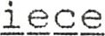 McKay, born October 6, 1910 at Lot 28, Conc. 11, East Zorra Twp. Carl worked before his marriage in Stratford at the CNR shops . He then bought a farm which they operated for several years in East Zorra Twp. They currently reside at 9 Lisa Street, Apt. 1103, in Bramalea, Ontario, where Carl is hospitalized following a stroke. They had 3 chilcE ren: Bob, Edwin and Catherine.
Below is a photo of Carl, and a group photo of Carl, Bob Williams, Ed, Jake and Walt, both taken at Ed' s farm in the 1940' s.
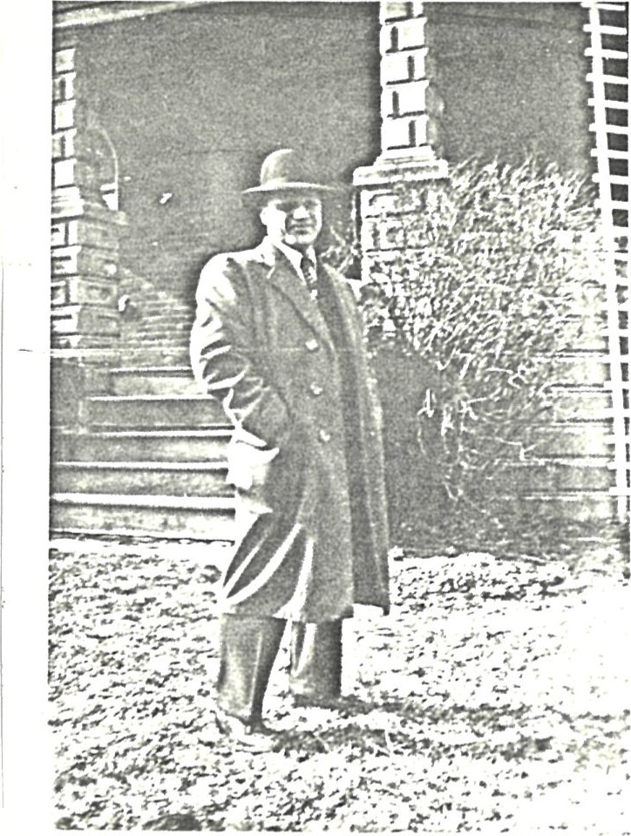
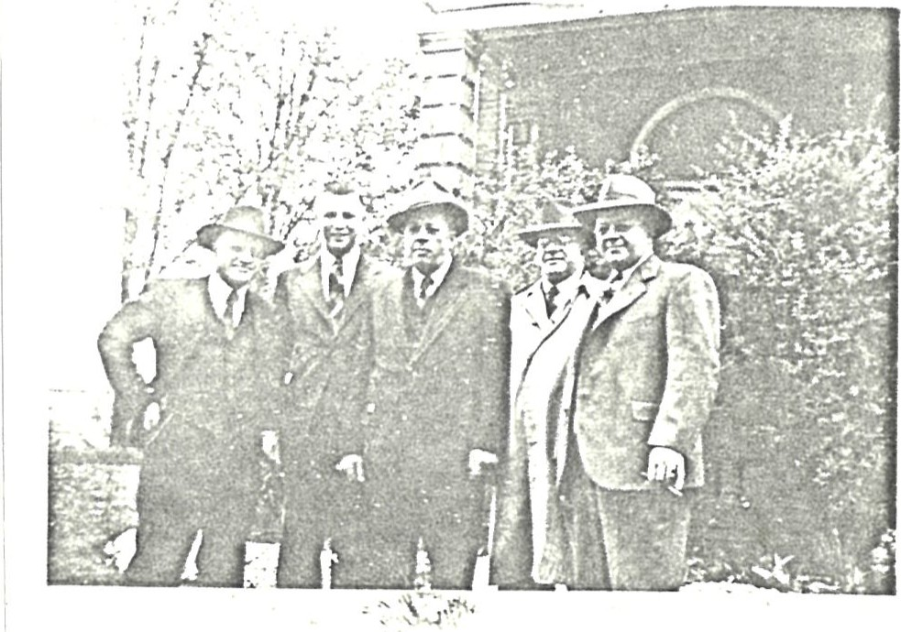
Berniece and Carl, April 28, 1951
Rose, Carl, Ida at Catherine's wedding
s
carl and Berniece, at Bob'May 30, 1981
Carl's 80th birthday
October 20, 1984
—74 a
IBI. Robert McKay Wilhelm, born March 30, 1944 at Stratford General Hospital; he was married December 26, 1970 at
St. Claire' s Roman Catholic Church, Rosedale , Long Island, NY to Michelle Jaqueline Pach, born August 6, 1948 at Irwin Hospital, Queens, NY . They are both professors at Miami University and he is currently working on a much more detailed Wilhelm family history with Joyce Kells McKenzie. Robert and Michelle live at 5758 Brown Road, Oxford, Ohio, USA 45056. Tel. ( 513) 523-6595 . They have two children:
IBII.  IB12.  1B2 .  1B21.  1B3 .  1B31.  1B32. | Celeste Raymonde, born April 18, 1975 at McCullough— Hyde Memorial Hospital, Oxford, Ohio .  Alexander Ryan McKay, born May 8, 197B at McCullough— Hyde Memorial Hospital, Oxford, Ohio .  Edwin John Wilhelm, born January 15, 1952 at Stratford General Hospital. He was married on December 23, 1983 at the United Church, Hill grade, Newfoundland , to Gwendolyn Gidge who was born December 24, 1957 . They live at 1506—2 Silver Maple Court, Bramalea, Ontario, L6T 4R1 Tel. (416) 451—8734, and they have one son,  Matthew Joseph Wilhelm, born March 30, 1985 at Peel Memorial Hospital, Brampton, Ontario .  Catherine Grace Wilhelm, born May 24, 1957 at Stratford General Hospital . She was married on May 30, 1981 at Trinity Lutheran Church, Sebastopol, to Michael Leonard Feren, born October 10 , 1959 . They live at 425 Rathburn Road E. , Mississauga, Ontario, (I don't have zip) and they have two daughters ,  Nadia Leta Feren, born April 2 , 1982 , at Western Hospital, Toronto, Ontario .  Alyssa Liana Feren, born April 13, 1988 in Mississauga, Ontario, 6 Lb . 11 oz.
Photos of this family are on the following page, 75a.

75
Bob and Michelle,
December 26, 1970
Edwin and Gwen, December 23 , 198.3
Catherine Feren and father, Carl May 30, 1981
Michael and Catherine Feren
May 30, 1981
7 5a
GEORGE ARNOLD WILHELM
George Arnold Wilhelm, born February 8 , 1907 at 74 Blake Street, Stratford, Ontario. He died ata age 3 of diphtheria on September 17, 1910. My dad used to tell us that Georgie had strawberry blonde ringlet curls said he was a darling! He is buried at, Avondale Cemetery, Stratford, Ontario, Canada.

THIS CONCLUDES THE FAMILY TREE FOR JOHN WILHELM

There is much more information out there and can and should be included. I can update this page by page if anyone is interested in adding to it or you can send further information to Robert McKay Wilhelm at 575B Brown Road, Oxford, OH 45056. He is compiling a much more thorough history complete with pictures, birth and death certificates, land purchases, deeds, but it is a very large undertaking and will take much more time to complete. Joyce Kells McKenzie is working with Robert on this huge task.
Her current address is 2000 S. Eads Street, Apt. 503, Arlington,
VA 22202 . However she and George planned to retire in 1986 and may be moving. She could be reached by contacting Rose Kells in Mitchell see listing for her address.
I have greatly enjoyed working on this history and 1 hope the readers find it of equal interest. Thanks for all your help special thanks to George and Lenore who (prodded' people for me. I couldn't have done it without you!
76

GEORGE ARNOLD WILHELM
George Arnold Wilhelm, born February 8 , 1907 at 74 Blake Street, Stratford, Ontario. He died ata age 3 of diphtheria on September 17, 1910. My dad used to tell us that Georgie had strawberry blonde ringlet curls said he was a darling! He is buried at Avondale Cemetery, Stratford, Ontario, Canada.

THIS CONCLUDES THE FAMILY TREE FOR #1, JOHN WILHELM
There is much more information out there' and can and should be included. I can update this page by page if anyone is interested in adding to it or you can send further information to Robert McKay Wilhelm at 5758 Brown Road, Oxford, OH 45056. He is compiling a much more thorough history complete with pictures, birth and death certificates, land purchases, deeds, but it is a very large undertaking and will take much more time to complete . Joyce Kells McKenzie is working with Robert on this huge task.
Her current address is 2000 S. Eads Street, Apt. 503, Arlington, VA 22202. However she and George planned to retire in 1986 and may be moving. She could be reached by contacting Rose Kells in Mitchell see listing for her address .
I have greatly enjoyed working on this history and I hope the readers find of equal Interest, . Thanks for all your help — special thanks to George and Lenore who ^{t} prodded' people for me, and to Florence Horman for her help with the King family. I couldn't have done it without you!
THIS IS A CONTINUATION OF THE FAMILY TREE OF THE OTHER CHILDREN OF SAMUEL AND MAGDALENA ISSLER WILHELM 2, 3 , AND 4.

2 . Jacob Wilhelm, born January 2, 1865, died February 4, 193B.
He was a veterinarian working in and around Shakespeare , Ontario . He was married ( 1 ) to Dietrich, who died and is buried at Trinity Lutheran Cemetery, Sebastopol . He moved to Saskatoon, Saskatchewan, and he married ( 2 ) Mildred Amelia Hess who was born June 4, 1867 in Phil a— delphia, PA and died January 9, 1943. They are buried at Woodlawn Cemetery, Saskatoon, Saskatchewan . They had three children:
2 1 . Joseph Oscar Henry Wilhelm was a professor at the University of Toronto. During the war (1939-1945) he was associated with the National Research Council and later received The Order of the British Empire . He married Nan Munroe from Saskatoon, Saskatchewan and they are both now deceased . They have two children, Donald and Mildred who are both married and have families, believed to be living in the Toronto area. I have no more information on them. Thanks to Nor ine Brueckner for this data.
- . Franklin Edward Wilhelm now deceased. He was a newspaperman with the Saskatoon Star Phoenix.
- . Magdalena Wilhelm, swallowed and died in infancy .
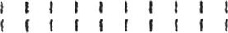
THIS ENDS THE INFORMATION 1 HAVE ON JACOB WILHELM
3 . Annie Wilhelm, born March 7 , 1865, on the farm near Shakespeare, Ontario She died on March 7 , 1951 . She was married on August 7 , 1894 to Oscar Brueckner, born July 31 , 1892 at St. Agatha, Ontario , and who died on January 1 , 1956 . He had worked as a tailor in Stratford. They are both buried at Avondale Cemetery , Stratford . They had three children.

31 . Magdalena Brueckner, (no birth date) taught school in Waterloo, Ontario . She married Rev. Clifford S. Roberts .
They had one daughter Dorothy, who died in infancy . Magdalena died April 19, 1971, and Clifford died on December 1 , 1979 .
.32 . J. Samuel Brueckner, born April 26, 1898 at Baden, Ontario. He moved to Stratford in 1899 with his family, and he worked as a machinist with the Canadian National Railway . He was married on December 24, 1925 at Sebastopol, Ontario to Alma Wittig, born March 6, 1900; they are now retired and live at 25 Kappele Circle, Stratford, Ontario N5A 6X4 . They had one daughter.
321 . Nor ine Anne Brueckner, born October 20, 1933; she was married at Zion Evangelical Lutheran Church, Stratford on September 15, 1956 to John Opper, born April 13, 1933. John worked for the Stratford Board of Education and is now with the Ministry of Education in London, Ontario. They have two children and they live at 1476 Roland Crescent, London, Ontario, N5X IE5, ( 519 ) 438-4895 .
- . Paul William Opper, born December 17, 1960 at Stratford, Ontario . He graduated in Urban Geography from the Univer— sity of Western Ontario. At present he manages a Computer store in London but continues to look for a position in his chosen field. On June 22, 1985 at Redeemer Lutheran Church in London he married Karin Elizabeth von Gernet . She is studying at the Faculty of Education, UWO, and they presently have no children.
- . Christine Elizabeth Opper, born March 8, 1965 in Stratford, Ontario . She attends the University of Western Ontario and is very active in the Lutheran Student Movement . She is not married .
John , Norine, Paul, Karin and Christine are all members of , and are actively involved in Redeemer Lutheran Church work in London, where Karin is the organist and choir director.

33 . Emma Brueckner, born April 16, 1901 at Stratford, Ontario. She taught for the Waterloo Board of Education. Several years after her sister Magdalena's death she married Clifford Roberts who is now deceased. She lives in Kitchener, Ontario .
THIS IS ALL THE INFORMATION 1 HAVE ON ANNIE WILHELM

4 . Elizabeth (Lizzie) Wilhelm, born April 3, 1870, on the farm near Shakespeare, Ontario . She died on October 4, 1 9.3 6 . She never married, and she lived most of her life with sister Annie and Oscar Brueckner. She was a practical nurse (I suppose we would call her a Red Cross Homemaker now from Florence King Horman) . She is buried at Avondale Cemetery, Stratford, Ontario.
THIS IS ALL THE INFORMATION 1 HAVE ON ELIZABETH WILHELM,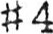

E N D M 1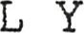T R E E
FAMILY OF THEODORE HEIDEMAN AND HULDA LUEDKE
Theodore Heideman, born in married to Hulda Luedke, born on died
They are buried in a Woodstock Cemetery .
Their children (correct order of birth not known)
1 . Robert Heideman, married Louisa Barkholder. They had four children :
1 1 . George
1 2 . Joseph
1 3 . Herbert
14 . Emma (Mrs . Walter Gison, 119 18th Ave. , NW , Calgary , Alta.
2 . Hulda Heideman, married Edward Schoenheide. They had four chi L dren .
21 . Theodore, married one son:
- 1 . Gerald Schoenheide, Indianapolis, IN 46260 .
- . Edward
- . Mary, married Archibald Pronger. Two ( ? ) children:
2.31 . Jean Pronger, married Howard A . Lennox. They live at 376 Hunter Street, Woodstock, Ontario.
232 . Audrey Pronger, married Dean . Their son died in the RCAF .
24 . August Heideman, married Maude He was murdered ( ? ) . They had a daughter, Kelly Inske, now Mrs. Lezetta, living in Crystal River, Florida. ( I may have misinterpreted this) .
3 . Rudolph Heideman (Big Albert) , married
They had three children, settled in Zurich.
31 . Albert
32 . Mrs . Hapel, R.R. Jackson, Mi chi gan
33 . Mrs . Beeman, 588 Piper Blvd. , Detroit , Michigan
- . Albert Heideman, married
They had one son, settled in Zurich. 41 . Rudolph, lives near Exeter, Ontario.
- . Edward Heideman, married They had two daughters .
- . Edith, married Meryn Coxworth. Lives in London, Ontario
- . married William Mason, lives in Toronto, Ontario
6 . Mary Heideman, married John Seltzer. They had seven children, and settled in Flint, Michigan.
- . Minnie, married George Robinson. Died 1963. They lived in Detroit , Michigan .
- . William.
6 .3 . John (never married) .
Adeline (never married) . Lived in Flint, Michigan.
- . Mary, married Coupland, lived in Flint, Michigan.
- . Margaret, (never married) .
- Eddie (never married?) .
Wilhelm Heideman, married
They had four children, settled in Shakespeare, Ontario.
7 1 . Nettie, married Will i lam Tilson
- . Mabel, married Oscar Stewart
- . Milton, never married
- . Girl child (#4) , died when young.
8 . Minnie Heideman, married John Wilhelm. They had 12 children and settled in Stratford, Ontario. Their family is chronicled on the previous pages.
The pictures in this section arrived after I had copied and collated the other 81 pages, but they are wonderful to have and I wanted to include them, so they are all on the following pages.
This is a picture of Minnie Heideman Wilhelm sitting in front of the side door at 74 Blake Street, Stratford, likely in the early 1940's — John Wilhelm' s wife, mother of 12, and progenitor of the more than 240 descendants chronicled in this booklet.
Below is real gem, a picture taken in the early 1890' s of baby Ida Wilhelm (King) and her grandmother Magdalena Issler Wilhelm, Samuel' s wife who would be ^{R} about 60' at the -time .
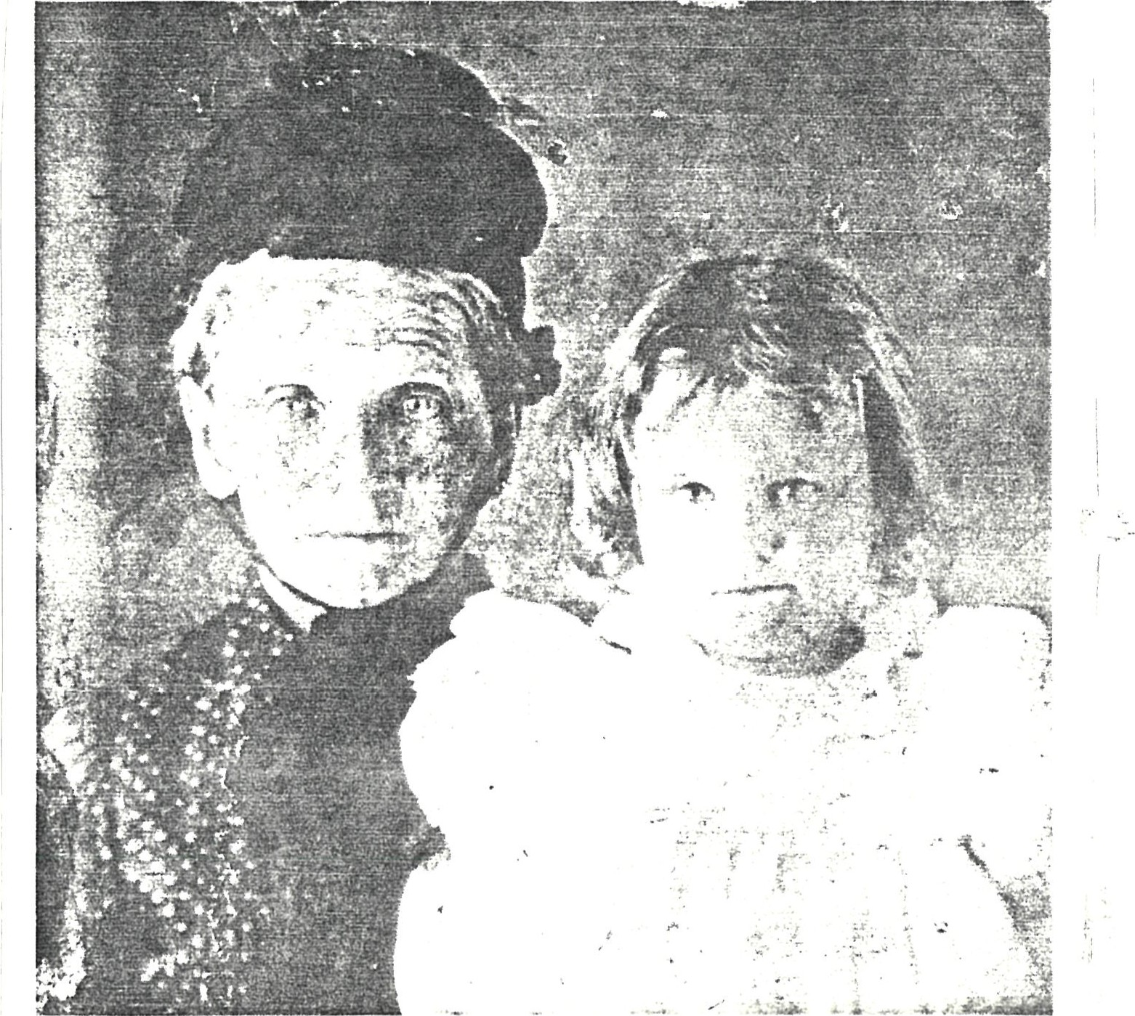

The Ida Wilhelm/ Frank King Wedding Party — the first, wedding performed at Zion Evangelical Lutheran Church, Stratford .
Best Man George Bradfield (North Bay) , Frank E. King, Ida Wilhelm King and Minnie Wilhelm, Bridesmaid.
Below are two pictures which were very dark and didn't copy too well, but they too are nice to have, especially since they both picture Minnie, also Jake's 2nd wife.
This is a photo showing Ida King, Edna Wilhelm (Bert' s wife) , Minnie Wilhelm, Flora (Ted's wife) , Emma (Ed' s wife) , Ida Williams (Jake' s 2nd wife) , Rose Kells and Minnie Kudob .
The picture below was likely taken in the early 1950' s but 1 am not sure of that . It shows Minnie Kudob, Flora, Emma, and Ted Wilhelm.
85
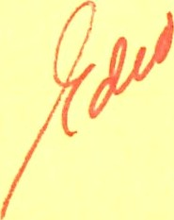
1 5 1 0 N . Darcy Avenue

S i mi va l l ey , CA 93065 F a l l 1 988
Dear Cous i ns ,
I t i s now a l most two years s i nce I f i rst d i s t r i buted the Wi l he l m H i s tory, and some updates were handed out l as t year at the reuni on but those who d i d not at tend di d not get them. Dur i ng the past year I ^{I} ve been rece i v i ng not i ces of b i rt hs , deaths , and correct i ons/ changes and I ^{I} ve f i na l l y been ab l e to i ncorpor ate a l l the i nformat i on i nto the book and pr i nt them out .
of you to ret ape p i c tures on any pages that have them before toss i ng out the o l d pages 1 ¹ m not phys i ca l l y up to doi ng i t a l l aga i n nor do I have the t i me .
I n any event , updated . You to do updates much paper! !  t i me l a te r i n | here are the update pages . I t ^{I} s up to you to keep your po rt i ons  f rom t i me to t i me, but somet i mes I mi s l ay the i nformat i on so I don I t l ose i t , 1 j ust mi s l ay i t and w i l l come ac ross i t some one of my many storage p l aces !
As we l l as the l oc a l W i l he lm c l an that was recorded i n the book , I ^{l} ve been abl e to t race the fami l y back th rough some tedi ous ( but i nt e res t i ng ! ) d i gg i ng at the Mormon Genea l og i ca l L i bra ry i n West Los Ange l es and have found Samue l ^{I} s fami l y back to h i s grandpa rents t h i s mi ght not be of i nterest to many of you, but i n case i t i s I I ve enc l osed those records . I am s t i l l t ry i ng to get i nformat i on f rom Mar i a ' s granddaugh ter i n Sa l t Lake C i ty, and have yet to f i nd any t race of Rudo l ph who emi grated to the States but I keep t ry i ng I f i nd that pa r t very f asc i nat i ng for some reason j us t l ea rni ng that our great grandfather was not j ust one person wh i ch i s a l l we previ ous ly knew , but came f rom a very l a r ge fami l y ( 1 1 ch i l dren i n a l l ) was so en l i ghteni ng you shou ld see the hundreds ª nd b...u-n...d....-..e-.-.-s- Of U i l he L ms L i s ted on the mi c rof i che card at the L i bra ry , and a lmost as many Weh r l i ^{l} s ( h i s mother ' s name) many of wh i ch were a l so named Anna - but on ly one of those ma rr i ed Johannes Wi l he lm!
** ADDRESS CHANGE ! ! **
Noe l and I w i l l be movi ng mi d- to end of November to our new , sma l l er semi ret i rement home j ust north of M i nden , N V and we are g reat l y ant i c i pat i ng the move to a much qu i eter envi ronment though much co l der i n w i nter l ! W e can stand the co l d , and there ^{I} s l i t t l e snow ^{l} on t h i s s i de of the S i e r ras ; our new home i s on a s l i gh t h i l l and faces the maj est i c S i er ra range , w i th the P i ne nut Mtns . beh i nd us we w i l l be part of the great Carson Va l l ey named af t e r K i t Carson , and about 6 mi l es south of the capi ta l , Carson C i ty . We w i l l be 1 3 mi l es east of Lake Tahoe i f we go over the l ove l y K i ngsbury G rade th rough the
S i er ras a few mi l es further i f we go a round on R t e . 395 to 50 and back down t o Tahoe . I t shou l d be peacefu l and pret ty . I th i nk a f te r set t l i ng i n for a few
l ef t ! I Be sure to note the address change and send l et te rs and future ent r i es to me there !
Noe l & Bette C l ark
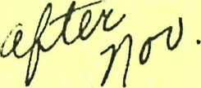
9-1
2957 Santa I nez D r i ve (M i ss i on Hot Spr i ngs )
M i nden, NV 89423 ( 702 ) . not yet known .
Anyway, I hope you enj oy these new pages and do put them away before they are m i s l a i d I know on l y too we l l how that goes . I ^{l} ve punched them a l l so you can j us t remove the o l d and repl ace w i th the new . For those of you who need mu l t i p l e copi es for your fami l i es you ^{I} l l have to copy them sor ry . 1 t r i ed to mi ni mi ze ma i l i ng and copyi ng cost s .
Keep i n touch , i t ^{I} s q reat to hear f rom the fami ly members !
